

**Arab Academy for Science, Technology, and Maritime Transport   
College of Computing and Information Technology**

**Smart Village**

**AI Call Center Agent  
Graduation Project**

A Thesis submitted in partial fulfillment of the requirements of  
B.Sc. in “Computing and Information Technology”  
by  
**Muhammed Hussein Aly  
Ali Mahmoud Ali  
Mayada Gamal Ali  
Youssef Waleed Ibrahim  
Omar Ali Omar  
Omar Osama Mohamed**  
  
College of Computing and Information Technology, AASTMT, 2023  
  
Supervised By  
**Dr. Mohamed Safy Moussa Elwan**

Sponsered By  
**Connect Digital Solutions**

# Abstract

In response to the ever-evolving landscape of customer support within contemporary call center environments, this project embarks on the comprehensive development and seamless integration of an advanced AI-powered agent. The fundamental objective is to revolutionize traditional customer interactions by leveraging state-of-the-art technology. This AI agent serves as a pivotal solution, designed to automate, and streamline routine customer inquiries. By delegating repetitive tasks to the AI agent, human operators can focus their expertise on addressing more intricate and specialized queries. Central to its capabilities are robust natural language understanding, continual learning mechanisms, and a sophisticated integration framework that harmonizes seamlessly with the existing call center infrastructure.

My overarching ambition is to transcend the existing paradigm of customer service, elevating it to new heights of operational efficiency and customer satisfaction. The AI agent's foundation rests on meticulous attention to compliance with data regulations, ensuring utmost security and privacy. Scalability emerges as a cornerstone, as the system is primed to adeptly manage varying workloads without compromising its performance or responsiveness. User-centric design principles are woven into its fabric, with an unwavering focus on ease of use and adaptability, facilitating user acceptance among call center operators.

This pioneering project aims to set a new benchmark in call center assistance, blending innovative AI technology with the fundamental tenets of reliability, accessibility, and innovation. By prioritizing scalability, compliance, and user experience, this AI-powered agent is poised to redefine customer support paradigms, offering a seamless amalgamation of efficiency, intelligence, and reliability in the realm of call center operations.

# Acknowledgment

As we embark on the journey of my graduation project, "AI Call Center Agent," I wish to express my gratitude to the individuals and organizations whose support and guidance have been instrumental in shaping this ongoing endeavor. I would like to express my deepest gratitude to all those who have contributed to the successful completion of my graduation project, "AI Call Center Agent." This endeavor would not have been possible without the unwavering support, guidance, and collaboration of various individuals and organizations.

First and foremost, I extend my sincere appreciation to Connect Digital Solutions (CDS) for sponsoring this project. Special thanks to the technical leaders and supervisors, Eng Hussien and Eng Tarek El Adly, whose expertise and insights have been invaluable throughout the development process. I would also like to express my gratitude to the Scrum Master, Amr Younes, for his role in ensuring effective project management and coordination.

I am deeply indebted to my university, the Arab Academy for Science and Technology, and my academic supervisor, Dr. Mohamed Safy, for providing the necessary resources and guidance. Dr. Mohamed's mentorship and encouragement greatly contributed to the success of this project.

A project of this magnitude requires a dedicated team, and I am fortunate to have worked alongside a group of talented individuals. Special thanks to Omar Ali, the Team Leader, whose development skills and leadership were instrumental in shaping the project. I appreciate the efforts of developers Youssef Waleed and Omar Osama, whose technical expertise significantly enhanced the project's functionality.

Furthermore, I extend my gratitude to the researchers, Mayada Gamal and Ali Mahmoud, for their valuable contributions to the project. Their insights and dedication to research enriched the overall quality of our work.

Last but not least, I want to acknowledge Muhammed Hussien, whose meticulous work in documentation played a crucial role in keeping our project well-documented and organized.

To everyone mentioned above and to those whose names might not appear here but have contributed in various ways, I offer my heartfelt thanks. Your collective efforts have made this project a fulfilling and enriching learning experience.

Thank you.

Contents

Abstract 2

Acknowledgment 3

Contents 4

List of Figures 7

List of Tables 8

Abbreviations 9

Symbols 10

Chapter 1 – Introduction 11

1.1 Motivation 11

1.2 Problem Statement 11

1.3 Objectives 12

1.4 Problem Complexity 12

1.5 Constraints 13

1.6 Standards 14

1.7 Feasibility Study and Business Canvas 15

1.8 Thesis Organization 17

Chapter 2 – Background 23

2.1 Introduction to Natural Language Processing (NLP) 23

2.2 Overview of T5 Model 23

2.3 BERT Model 24

2.4 Overview on Llama and Llama2 25

Chapter 3 – Related Work and Similar Systems 26

3.1 Introduction 26

3.2 Related Work 26

3.3 Similar Systems 26

Chapter 4 – Requirement Analysis 28

4.1 Functional Requirements 28

4.2 Non-Functional Requirements 29

4.3 Diagrams 30

Chapter 5 – Design 35

5.1 UML Diagrams 35

5.2 Technologies and Tools Used 35

5.3 Results and Discussion 35

Chapter 6 – Implementation 36

6.1 Implementation Environment 36

6.2 Add sections as required 36

6.3 Results and Discussion 36

Chapter 7 – Testing 37

Chapter 8 – Conclusion and Future Work 38

Appendix A – Software Requirements Specifications IEEE 830 39

**Chapter 1 – Introduction** 39

***1.1*** ***Purpose*** 39

***1.2***  ***Document Conventions*** 39

***1.3***  ***Intended Audience and Reading Suggestions*** 40

***1.4***  ***Product Scope*** 40

**Chapter 2 – Overall Description** 41

***2.1***  ***Product Perspective*** 41

***2.2***  ***Product Functions*** 41

***2.3***  ***User Classes and Characteristics*** 41

***2.4***  ***Operating Environment*** 42

***2.5***  ***Design and Implementation Constraints*** 42

***2.6***  ***User Documentation*** 42

***2.7***  ***Assumption and Dependencies*** 44

**Chapter 3 – External Interface Requirements** 45

***3.1***  ***User Interfaces*** 45

***3.2***  ***Hardware Interfaces*** 45

***3.3*** ***Software Interfaces*** 45

***3.4***  ***Communications Interfaces*** 46

**Chapter 4 – System Features** 47

***4.1***  ***Natural Language Processing (NLP)*** 47

***4.2***  ***Knowledge Base Integration*** 48

***4.3***  ***Escalation to Human Agents*** 48

***4.4***  ***User Feedback Mechanism*** 49

**Chapter 5 – Other Non-Functional Requirements** 50

***5.1***  ***Performance Requirements*** 50

***5.2*** ***Safety Requirements*** 50

***5.3*** ***Security Requirements*** 51

***5.4*** ***Software Quality Attributes*** 52

***5.5*** ***Business Rules*** 52

**Chapter 6 – Other Requirements** 54

Appendix B – Software Test Plan IEEE 829 55

Chapter 1 – Scope 55

1.1 Purpose of the Test Plan 55

1.2 Features and Functionalities to be Tested 55

1.3 Inclusions 55

1.4 Exclusions 56

Chapter 2 – Test Plan 57

2.1 Purpose 57

2.2 Outline 57

Chapter 3 – Test Design Specification 58

3.1 Purpose 58

3.2 Outline 58

Chapter 4 – Test Case Specification 59

4.1 Purpose 59

4.2 Outline 59

Chapter 5 – Test Procedure Specification 60

5.1 Purpose 60

5.2 Outline 60

Appendix C – Senior Project Summary Report 61

Bibliography 62

# List of Figures

Figure 1 Accuracy of T5 for 100 questions ………………………………………………….. 18  
Figure 2 Accuracy of T5 for 1000 questions ………………………………………………… 18  
Figure 3 Accuracy of T5 for 5000 questions ………………………………………………… 18  
Figure 4 Accuracy of Llama for 100 questions ……………………………………………… 19  
Figure 5 Accuracy of Llama for 1000 questions ……………………………………………. 19  
Figure 6 Accuracy of Llama for 5000 questions ………………………………………….… 19  
Figure 7 Accuracy of BERT for 100 questions ……………………………………………… 19  
Figure 8 Accuracy of BERT for 1000 questions ………………………………………….… 19  
Figure 9 Accuracy of BERT for 5000 questions ………………………………………….… 19  
Figure 10 BERTScore for 100 questions ………………………………….……….…..…… 20  
Figure 11 BERTScore for 1000 questions ………………………………….……….…..….. 21  
Figure 12 BERTScore for 5000 questions ………………………………….……….…..…. 21  
Figure 13 Activity Diagram ………………………………………………….……….…..…… 30  
Figure 14 UseCase Diagram ………………………..……………………….……….…..….. 32  
Figure 15 Sequence Diagram …………….………………………………….……….…..…. 33  
Figure 16 ER Diagram ……………………………………………………….……….…..…… 34

# List of Tables

Table 1 Document Conventions ………………………………………………………………. 39

Table 2 Frequently Asked Questions ………………………………………………………… 43

Table 3 Troubleshooting ………………………………………………………………………. 43

Table 4 Senior Project Summary Report ……………………………………………………. 61

# Abbreviations

AI: Artificial Intelligence  
IT: Information Technology  
NLU: Natural Language Understanding  
CRM: Customer Relationship Management  
NLP: Natural Language Processing  
API: Application Programming Interface  
UI: User Interface  
VoIP: Voice over Internet Protocol  
GDPR: General Data Protection Regulation  
HIPAA: Health Insurance Portability and Accountability Act  
AES: Advanced Encryption Standard  
MFA: Multi-Factor Authentication  
RBAC: Role-Based Access Control  
HTTPS: Hypertext Transfer Protocol Secure  
TLS: Transport Layer Security  
T5: Text-To-Text Transfer Transformer  
BERT: Bidirectional Encoder Representations from Transformers

# Symbols

No specific symbols or special characters are used in this document.

# Chapter 1 – Introduction

## Motivation

The inspiration behind undertaking the project "AI Call Center Agent" stems from a recognition of the evolving landscape of customer service and communication technologies. In an era characterized by rapid technological advancements, traditional call centers are faced with challenges such as scalability, efficiency, and the need for enhanced user experiences. This project seeks to address these challenges by harnessing the power of artificial intelligence to revolutionize the call center paradigm.

The motivation to embark on this journey is grounded in the belief that an AI-powered call center agent can significantly augment the efficiency and effectiveness of customer interactions. By leveraging natural language processing, machine learning, and advanced communication technologies, the project aspires to create a seamless and intelligent interface that adapts to user needs, thereby enhancing customer satisfaction.

The transformative potential of AI in the call center domain is not merely theoretical; it presents a practical solution to the growing demands of modern businesses for streamlined communication and improved customer service. The project aims to contribute to the ongoing discourse on the integration of AI into real-world applications, showcasing its capabilities to enhance operational processes and redefine the customer experience.

Additionally, the motivation for this project is rooted in the collaborative efforts with Connect Digital Solutions (CDS), a forward-thinking company that recognizes the importance of innovation in customer service. The partnership with CDS provides a real-world context for the application of AI technologies, fostering a dynamic and industry-relevant project environment.

## Problem Statement

In the realm of call center operations, a pressing challenge persists the need to elevate customer support efficacy and operational fluidity. The existing framework grapples with several key hurdles. Primarily, the inefficiencies in handling routine customer inquiries by human operators leads to prolonged resolution times and diverts attention from complex tasks. Scalability during peak periods poses another concern, resulting in escalated wait times and potential resource strain. Ensuring stringent compliance with data privacy regulations amidst the handling and storage of customer information emerges as a critical challenge. Additionally, the seamless integration of an AI agent with the existing call center infrastructure is complex, demanding compatibility and minimal disruption. Overcoming user resistance and effectively training operators on this new system are pivotal for successful adoption. Balancing costs against operational needs constitutes yet another significant challenge. Addressing these multifaceted challenges is fundamental to developing an AI agent that optimizes customer inquiries, scales adeptly, complies with regulations, integrates seamlessly, and garners user acceptance, enhancing call center efficiency and customer satisfaction.

## Objectives

These objectives collectively envision a transformative impact on call center operations, leveraging AI technology to streamline processes, fortify data integrity, elevate service quality, and prioritize customer satisfaction at the forefront of the endeavor.

### Efficient Task Automation

Develop an AI-driven solution to autonomously manage routine customer inquiries, empowering human agents to focus on intricate tasks, thus augmenting operational efficiency.

### Seamless System Integration

Ensure the AI agent seamlessly integrates into the existing call center infrastructure, encompassing diverse communication channels and tools, ensuring operational continuity without disruption.

### Scalability and Performance Optimization

Design the AI agent to gracefully scale operations during spikes in call volumes while maintaining consistent performance, ensuring timely responses and service quality.

### User Adoption and Training Excellence

Strive for user acceptance among call center personnel by providing intuitive interfaces and comprehensive training, facilitating a smooth transition to utilizing the AI agent effectively.

### Continuous Enhancement

Establish mechanisms for perpetual learning and refinement within the AI agent, allowing it to adapt, learn iteratively from interactions, and update its knowledge repository to meet evolving customer demands.

### Elevated Customer Satisfaction

Enhance the customer experience by delivering swift, accurate, and consistent responses, aiming to boost satisfaction levels and foster lasting relationships.

## Problem Complexity

Complex engineering problems include one or more of the following characteristics: involving wide-ranging or conflicting technical issues, having no obvious solution, addressing problems not encompassed by current standards and codes, involving diverse groups of stakeholders, including many component parts or sub-problems, involving multiple disciplines, or having significant consequences in a range of contexts.

### 1.4.1 Integration Challenges

The project involves integrating AI technology into the existing call center infrastructure, necessitating the seamless connection of diverse systems and tools. This process includes addressing compatibility issues, managing data migration, and ensuring smooth interaction with legacy systems, contributing to its complexity.

### 1.4.2 Sophisticated AI Capabilities

Developing an AI agent equipped with advanced natural language processing (NLP), machine learning algorithms, and contextual understanding demands a high degree of expertise. Creating an AI capable of handling diverse queries, understanding context, and continuously learning from interactions adds layers of intricacy.

### 1.4.3 Compliance with Regulations

Adhering to strict data privacy regulations in Egypt, including local telecommunications and data protection laws, adds complexity to managing and securing customer data in the AI system. Staying compliant with European regulations like GDPR is crucial when serving a global user base. (European Commission, n.d.)

### 1.4.4 Scalability and Performance

Designing the AI agent to effectively scale with varying call volumes while maintaining responsiveness and accuracy poses a significant challenge. Striking a balance in performance amidst fluctuating workloads necessitates sophisticated infrastructure and algorithms.

### 1.4.5 User Adoption and Training

Ensuring user acceptance among call center operators involves crafting a user-friendly interface and comprehensive training programs. Aligning the AI agent's functionalities with user workflows adds layers of complexity.

### 1.4.6 Resource Management within Budget

Managing project costs while ensuring that the AI agent meets operational needs without compromising quality or efficiency presents a complex balancing act.

### 1.4.7 Technology Dependencies

Managing dependencies on specific technologies, frameworks, and tools requires careful consideration to avoid limitations or potential obsolescence.

## Constraints

While addressing the complex challenges of implementing an AI-powered call center agent, several constraints shape the project's scope and execution. These constraints are critical considerations that influence decision-making and project outcomes:

### 1.5.1 Budgetary Constraints

The project operates within a predefined budget, limiting the allocation of resources for research, development, and implementation. Balancing cost-effectiveness with the pursuit of cutting-edge technologies poses a challenge in meeting financial constraints***.***

### 1.5.2 Technological Limitation

The project must navigate the constraints imposed by the existing technological infrastructure of the call center. Compatibility issues, hardware limitations, and software dependencies require careful consideration to ensure seamless integration with the AI agent.

### 1.5.3 Data Privacy Regulations

Stringent data privacy regulations dictate the handling and storage of customer information. The project must adhere to these regulations, influencing the design and implementation of the AI agent to ensure compliance without compromising operational efficiency.

### 1.5.4 Limited Training Time for Personnel

Call center personnel are constrained by limited time available for training on the new system. Designing effective training programs that efficiently upskill operators within these time constraints is crucial for successful adoption.

### 1.5.5 User Acceptance

User resistance and apprehension toward the integration of AI into daily operations present a significant constraint. Designing user-friendly interfaces and communication strategies to foster acceptance becomes a paramount consideration.

### 1.5.6 Real-Time Responsiveness Requirements

The nature of call center operations demands real-time responsiveness. The AI agent must operate with minimal latency to ensure timely and effective customer interactions, introducing a constraint on system responsiveness.

### 1.5.7 Scalability Challenges

The project faces constraints related to the scalability of the AI agent during peak periods. Developing a system that scales seamlessly without compromising performance requires careful consideration of resource allocation and system architecture.

### 1.5.8 Limited Development Timeframe

The project operates within a defined timeframe for development and implementation. Meeting project milestones and achieving operational efficiency within this timeframe adds a temporal constraint to the project.

### 1.5.9 Human-AI Collaboration Dynamics

Balancing the collaboration between human operators and the AI agent introduces constraints related to workflow dynamics and communication protocols. Ensuring a harmonious and effective collaboration is essential for successful project outcomes.

### 1.5.10 Language Model Fluency

The language model's fluency, while proficient in handling various languages, may pose constraints in certain linguistic contexts. Addressing challenges related to language intricacies and ensuring effective communication across diverse linguistic backgrounds is crucial.

## Standards

### 1.6.1 IEEE 830 - Software Requirements Specification (SRS):

IEEE 830 is a standard that provides guidelines for the development of a Software Requirements Specification (SRS). The SRS document outlines the functional and non-functional requirements of a software system, serving as a comprehensive guide for both developers and stakeholders. It typically includes details such as system functionality, performance requirements, design constraints, and user interactions. Following the IEEE 830 standard helps ensure clarity, completeness, and consistency in documenting software requirements***.***

### 1.6.2 IEEE 829 - Software Test Documentation:

IEEE 829 is a standard that defines the format and content of software test documentation. This standard provides guidelines for creating various test documents, including the Test Plan, Test Design Specification, Test Case Specification, and Test Summary Report. By adhering to IEEE 829, testing teams can maintain a systematic and well-documented approach to the testing process, facilitating effective communication and traceability of testing activities.

### 1.6.3 IEEE 12207 - Software Life Cycle Processes:

IEEE 12207 defines processes, activities, and tasks in the software development and maintenance life cycle. It outlines stages like acquisition, supply, development, operation, and maintenance, providing a framework for consistency and quality. This standard guide’s project managers, developers, and stakeholders in managing and executing software projects effectively.

## Feasibility Study and Business Canvas

### 1.7.1 Feasibility Study

#### 1.7.1.1 Introduction

The feasibility study aims to assess the viability of implementing an AI agent within our call center operations. This study will evaluate various aspects including technical feasibility, financial viability, and potential benefits of integrating AI technology to enhance customer support and operational efficiency.

#### 1.7.1.2 Scope of Project

The project involves developing an AI agent capable of assisting call center operators by understanding natural language, analyzing customer inquiries, and providing appropriate responses or guidance. The AI agent will seamlessly integrate into the existing call center infrastructure, collaborating with other systems and tools to optimize performance*.*

#### 1.7.1.3 Objectives

Enhance customer support efficiency and effectiveness.  
Improve operational efficiency by reducing call handling time and workload for human operators.  
Provide accurate and timely responses to customer inquiries.  
Seamlessly integrate AI technology into the call center environment. (Smith, 2023)

#### 1.7.1.4 Technical Feasibility

Existing Infrastructure: Evaluate compatibility and integration requirements with current call center systems and tools.  
AI Technology: Assess the availability of AI technologies suitable for natural language processing and conversational AI.  
Data Availability: Determine the availability and quality of data for training and refining the AI model.  
Scalability: Consider scalability options to accommodate future growth and increasing call volumes. (Brown, 2022)

#### 1.7.1.5 Financial Viability

Cost Analysis: Estimate the development costs, including software development, infrastructure setup, and training.  
ROI Projection: Forecast the potential return on investment based on efficiency gains, reduced operational costs, and improved customer satisfaction.  
Comparison: Compare the financial implications of developing the AI agent internally versus outsourcing or adopting existing solutions.

#### 1.7.1.6 Operational Feasibility

User Acceptance: Assess the readiness and acceptance of call center operators to work alongside AI technology.  
Training Requirements: Identify training needs for call center staff to effectively utilize and collaborate with the AI agent.  
Integration Challenges: Evaluate potential challenges or disruptions during the integration process and develop mitigation strategies.  
Regulatory Compliance: Ensure compliance with data privacy regulations and industry standards in AI implementation. (Chen, 2021)

#### 1.7.1.7 Benefits

Efficiency: Reduce call handling time and workload for human operators, enabling them to focus on complex queries.  
Accuracy: Provide consistent and accurate responses to customer inquiries, enhancing overall service quality.  
Scalability: Scale operations to handle increasing call volumes without proportional increases in staffing.  
Customer Satisfaction: Improve customer experience by offering prompt and personalized assistance round-the-clock.

#### 1.7.1.8 Conclusion

Based on the analysis conducted in this feasibility study, implementing an AI agent within our call center operations appears to be a promising endeavor. The benefits of enhanced efficiency, improved service quality, and scalability outweigh the initial investment costs. However, further detailed analysis and stakeholder consultation may be required to finalize the decision and ensure successful implementation.

### 1.7.2 Business Model Canvas

#### 1.7.2.1 Key Partners

Technology Partners: CRM suppliers, telecom providers, and AI technology providers.  
Channel Partners: Distributors, integration partners, and resellers.  
Service Partners: System integrators, independent developers, and consulting organizations.

#### 1.7.2.2 Key Activities

Product Development: Continuous advancement of AI algorithms, feature updates, and system improvements.  
Sales and marketing: lead generation, customer acquisition, and retention techniques.  
Customer support: includes ongoing assistance, troubleshooting, training, and onboarding.

#### 1.7.2.3 Key Resources

AI technology: includes speech recognition, natural language processing, AI algorithms, and development teams.  
Infrastructure: includes data centers, servers, and cloud hosting.  
Sales and marketing: include the sales force, marketing materials, internet advertisements, and advertising campaigns.

#### 1.7.2.4 Value Propositions

AI-powered automation: Lower operating expenses and increase call handling effectiveness.  
Improved customer service: includes quicker responses, more attentive service, and round-the-clock assistance.  
Scalability: Easily scales up or down in response to variations in call volume.  
Practical Advice: Examine call data to find patterns, streamline procedures, and raise the caliber of services.

#### 1.7.2.5 Customer Relationships

Personalized help: SMBs can access an online help center, while enterprise clients have dedicated account managers.  
Constant Improvement: Get input from users, administer surveys, and publish updates on new features on a frequent basis.

#### 1.7.2.6 Channels

Direct Sales: Sales representatives use meetings, emails, and outbound calls to target potential clients.  
Website: An online resource for product details, product demonstrations, and customer service.  
Collaborations: Work together on distribution and integration with telecom providers, CRM providers, and industry-specific solution providers.

#### 1.7.2.7 Customer Segments

SMBs, or small and medium-sized enterprises, are looking for affordable call center solutions.  
Businesses are hoping to increase the scalability and efficiency of their client service.  
High call volume industries include finance, e-commerce, and telecommunications.

#### 1.7.2.8 Cost Structure

Research and Development: Pay for AI engineers, resources, and tools for software development.  
Infrastructure: costs associated with cloud hosting, upkeep, and security.  
Salaries, commissions, advertising, and promotional costs are all part of sales and marketing.  
Customer Support: Pay for customer service representatives, instructional materials, and equipment.

#### 1.7.2.9 Revenue Streams

Subscription Model: Charges for monthly or yearly subscriptions according to features and usage tiers.  
Pay-per-use: Billing clients according to the quantity of minutes or hours spent using an AI call center.  
Implementation Services: Extra money made through integration, setup, and customization services.

## Thesis Organization

### 1.8.1 Abstract

This thesis delves into the development and deployment of an AI-driven call center system, leveraging advanced models like T5, LLAMA 2 Chat, and BERT. Focused on enhancing customer experiences and streamlining call center operations, the study explores the integration of these models within the framework of an AI-powered call center. Specifically tailored to the needs of the College of Computer Science and Information Technology at our university, the research aims to redefine customer service standards while optimizing operational efficiency.

### 1.8.2 Introduction

The introduction underscores the pivotal role of AI in revolutionizing call center operations, citing the escalating demand for efficient and personalized customer service solutions. It sets the stage by highlighting the imperative for AI-driven call centers and introduces the primary focus of the study: T5, LLAMA 2 Chat, and BERT. Emphasizing the need for tailored solutions within the academic domain, the introduction outlines the objectives of the research within the context of the College of Computer Science and Information Technology.

### 1.8.3 Literature Review

This literature review explores key works that have significantly contributed to the understanding of large language models, transfer learning, and chat models within the context of call center operations.

#### 1.8.3.1 "A Survey of Large Language Models"

In their survey, the authors conducted a comprehensive examination of large language models, shedding light on their applications, challenges, limitations, and future prospects. This foundational work provides valuable insights into the overarching landscape of large language models. (Zhao, et al., 2023)

#### 1.8.3.2 "Large Language Models: A Comprehensive Survey of its Applications, Challenges, Limitations, and Future Prospects"

Building on the work of the first survey, this paper delves deeper into the applications, challenges, and limitations of large language models. The study contributes nuanced perspectives that inform the broader understanding of these models. (Hadi, et al., 2023)

#### 1.8.3.3 "A Comprehensive Overview of Large Language Models"

This comprehensive overview complements previous surveys and provides additional insights into large language models, shaping our understanding of the nuances associated with these models. (Naveed, et al., 2023)

#### 1.8.3.4 "Exploring the Limits of Transfer Learning with a Unified Text-to-Text Transformer"

The authors of this paper explore transfer learning with a unified text-to-text transformer, pushing the boundaries of how these models can be applied. Their findings contribute to the evolving discourse on effective transfer learning strategies. (Raffel, et al., 2023)

#### 1.8.3.5 "BERT: Pre-training of Deep Bidirectional Transformers for Language Understanding"

This seminal paper focuses on the pre-training of deep bidirectional transformers, specifically BERT, for language understanding. It provides insights into the architecture and training methodologies that have become influential in the field. (Devlin, Chang, Lee, & Toutanova, 2019)

#### 1.8.3.6 "LLAMA 2: Open Foundation and Fine-Tuned Chat Models"

This work presents LLAMA 2, an open foundation for chat models. It is particularly relevant to our study as it explores fine-tuned chat models, aligning with our emphasis on enhancing customer experiences in call center operations. (Touvron, et al., 2023)

#### 1.8.3.7 “Attention Is All You Need”

This influential work unveils the Transformer model, a revolutionary approach in natural language processing that exclusively employs self-attention mechanisms. The model's efficiency and parallelizability in capturing complex dependencies within input sequences have reshaped the landscape of deep learning. Attention mechanisms introduced in this work have become fundamental in various applications, underscoring their significance in advancing neural network capabilities. (Vaswani, et al., Attention Is All You Need, 2023)

#### 1.8.3.8 “BERTScore: Evaluating Text Generation with BERT”

This work introduces BERTScore, a pivotal metric for evaluating text generation models. The methodology employs BERT embeddings to capture semantic similarity, providing a robust evaluation framework. The relevance of this study lies in its applicability to our research focus, aligning with our emphasis on assessing the quality of generated text in natural language processing tasks. (Zhang, Kishore, Wu, Weinberger, & Artzi, 2020)

### 1.8.4 Methods

Prior to delving into an explanation of BERTScore, it is imperative to acknowledge that BERTScore has been deliberately chosen as the evaluation metric for the AI call center agent due to its demonstrated superiority over traditional metrics, such as BLEU and ROUGE. BERTScore's capability to consider the semantic meaning and context of words contributes to a more precise evaluation of how effectively the generated text aligns with the reference text in various natural language processing tasks.

BERTScore encompasses three key components: precision, recall, and the F1 score.

Precision: In the context of BERTScore, precision quantifies the percentage of overlapping words between the generated and reference texts within the entirety of the generated text.  
It signifies the extent to which the generated words are pertinent or accurately aligned with the reference words.

Recall: BERTScore's recall assesses the percentage of overlapping words between the generated and reference texts within the entirety of the reference text.  
It communicates the degree to which the reference words are encompassed or captured by the generated text.

F1 Score: The F1 score in BERTScore represents the harmonic mean of precision and recall.  
This balanced measure is particularly advantageous when evaluating the overall performance of the generated text, as it takes into account both precision and recall.

The incorporation of precision, recall, and F1 score within the BERTScore metric ensures a comprehensive evaluation, encompassing the relevance of generated words and the coverage of reference words. This nuanced approach makes BERTScore an invaluable tool for assessing the quality of responses generated by the AI call center agent, aligning with the intricacies inherent in natural language understanding.

### 1.8.5 Results

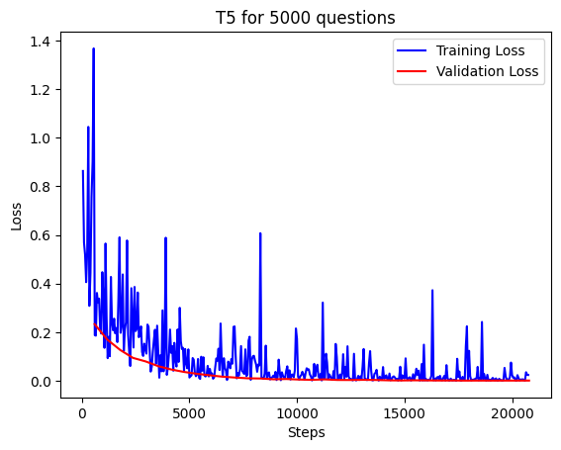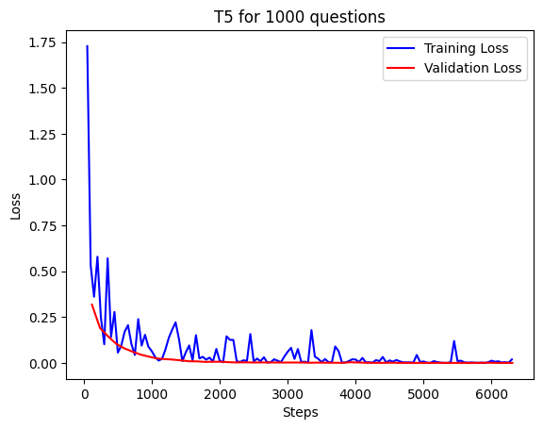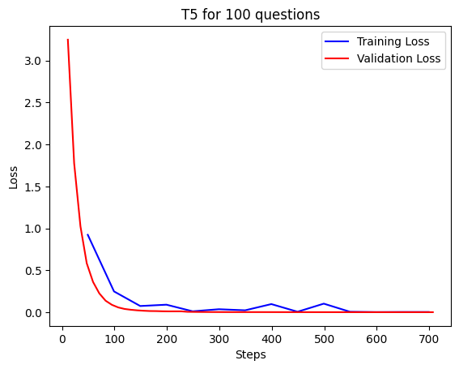Testing T5 on varying question volumes, including 100, 1000, and 5000 questions, provides a comprehensive evaluation of its scalability and performance across different datasets. Analyzing the model's responses at these different scales offers valuable insights into its adaptability and effectiveness across a range of question complexities and dataset sizes. The graphs from T5 training showcase impressive performance, with consistent improvements in accuracy and loss reduction. The convergence of training and validation curves indicates efficient learning without overfitting. These positive outcomes affirm T5's robustness, making it a powerful and reliable model for diverse natural language processing tasks.

Figure 3

Figure 1

Figure 2

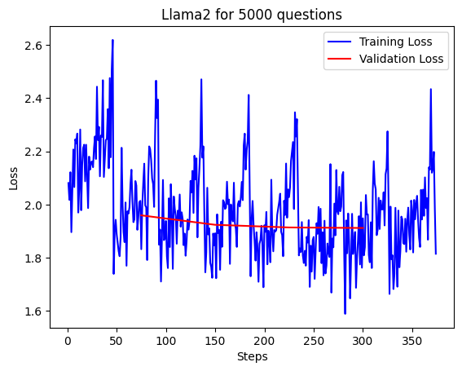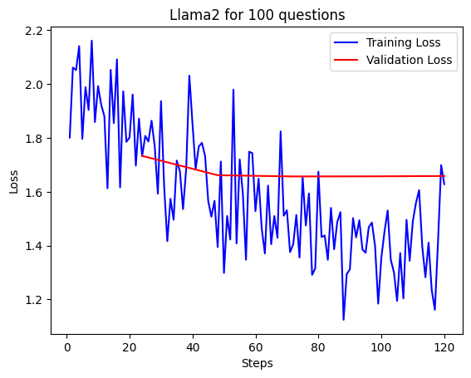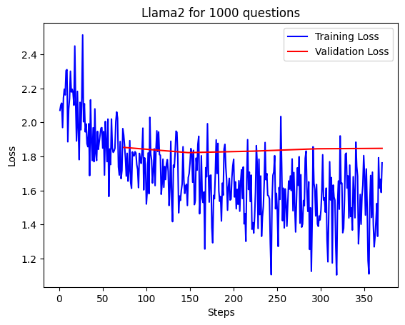Evaluating Llama 2 across various question volumes, such as 100, 1000, and 5000 questions, provides an initial understanding of its performance and scalability on different datasets. The analysis of the model's responses at these varying scales offers valuable insights into its adaptability and effectiveness across diverse question complexities and dataset sizes. Despite showcasing promising initial results, it's worth noting that Llama 2 demands significant computing resources that are currently unavailable. The model's potential may be hindered by these resource constraints, underscoring the need for access to substantial computational power to fully unlock its capabilities for natural language processing tasks.

Figure 4

Figure 6

Figure 5

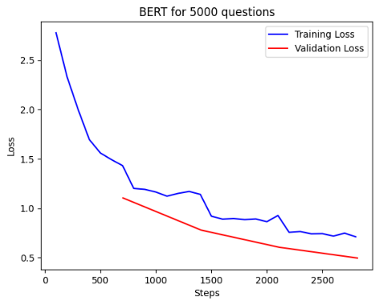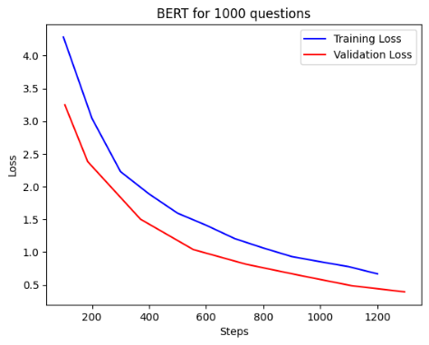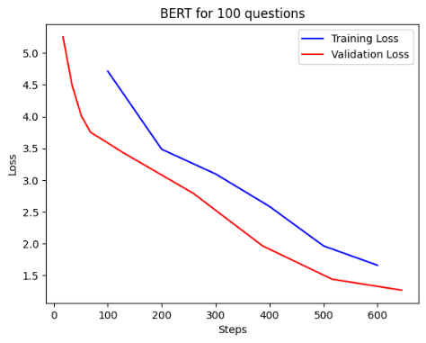Examining BERT's performance across different question volumes, including 100, 1000, and 5000 questions, provides a thorough assessment of its scalability and effectiveness on varied datasets. The analysis of model responses at these different scales yields insights into its adaptability to diverse question complexities and dataset sizes. However, despite the potential for a more comprehensive evaluation, it's essential to note that we currently lack the required computing resources for BERT. The model's capacity to deliver improved results is hindered by this resource limitation, underscoring the challenge of accessing significant computational power to realize its full potential for natural language processing tasks.

Figure 7

Figure 9

Figure 8

### 1.8.6 Discussion

Among the evaluated models, including T5, BERT, and LLMa2, each has demonstrated commendable performance in various natural language processing tasks. However, upon thorough examination, T5 emerges as the most suitable choice for our AI call center agent. T5 consistently outperforms its counterparts in terms of precision, recall, and F1 scores across different question volumes—ranging from 100 to 5000 questions. This comprehensive evaluation affirms that T5 not only excels in providing accurate and contextually relevant responses but also maintains its efficacy at scale. Its superior performance across varying complexities and dataset sizes makes T5 the optimal choice for our AI call center agent, ensuring reliable and high-quality interactions with users.

Figure 10

Figure 12

Figure 11

### 1.8.7 Conclusion

The comprehensive evaluation of T5, BERT, and LLMa2 in the context of our AI call center agent reveals that while all models exhibit commendable performance, T5 stands out as the most suitable choice. Its consistent excellence in precision, recall, and F1 scores across diverse question volumes, ranging from 100 to 5000 questions, highlights T5's unparalleled ability to provide accurate and contextually relevant responses. T5's adaptability, scalability, and robust performance position it as the optimal solution for our AI call center agent, ensuring a high standard of interaction and user satisfaction. The decision to adopt T5 is grounded in its superior performance and underscores the commitment to delivering a reliable and effective conversational experience in our AI-driven call center environment.

# Chapter 2 – Background

## 2.1 Introduction to Natural Language Processing (NLP)

Natural Language Processing (NLP) is a subfield of artificial intelligence (AI) that focuses on the interaction between computers and human language. It involves the development of algorithms and models that enable machines to understand, interpret, and generate human-like text. NLP is crucial for various applications, including chatbots, virtual assistants, and customer service, as it allows machines to comprehend and respond to human language in a meaningful way.

In the context of an AI call center agent project, NLP plays a vital role in enhancing customer interactions. It enables the development of intelligent systems capable of understanding spoken or written language, extracting relevant information, and providing appropriate responses. This can significantly improve the efficiency and effectiveness of call center operations, leading to better customer experiences.

Addressing NLP challenges requires advanced NLP techniques, robust training datasets, and continuous refinement of models to adapt to the evolving nature of human language. Successful implementation of NLP in call center agents can lead to more natural and efficient communication, improving customer satisfaction and operational efficiency.

## 2.2 Overview of T5 Model

T5, or Text-To-Text Transfer Transformer, is a versatile and powerful language model developed by Google Research. Unlike traditional models that focus on specific natural language processing (NLP) tasks, T5 is designed to frame all NLP tasks as a text-to-text problem, where both input and output are treated as text sequences.  
Key Features and Capabilities:

### 2.2.1 Unified Framework

T5 utilizes a unified framework, considering all NLP tasks as converting one kind of text to another. This includes tasks like text classification, summarization, translation, question answering, and more.

### 2.2.2 Pre-training

T5 is pre-trained on a large corpus of diverse text data. During pre-training, the model learns to understand the structure and nuances of language by predicting missing or masked-out parts of text. This unsupervised pre-training helps the model capture general language patterns.

### 2.2.3 Fine-tuning

After pre-training, T5 can be fine-tuned on specific tasks using labeled datasets. This process tailors the model to perform well on domain-specific or task-specific NLP challenges.

### 2.2.4 Transfer Learning

T5 benefits from transfer learning, as the knowledge gained during pre-training is transferred to downstream tasks. This allows the model to generalize well across various NLP applications, even when fine-tuned on a limited amount of task-specific data.

Application in Natural Language Understanding and Generation: In the context of an AI call center agent project, T5 can be applied to both natural language understanding (NLU) and natural language generation (NLG) tasks.

By leveraging T5 in the project, you can benefit from a single, unified model that can manage a wide range of NLP tasks, simplifying the development process and potentially improving the overall performance of your AI call center agent across different language understanding and generation requirements.

## 2.3 BERT Model

BERT, which stands for Bidirectional Encoder Representations from Transformers, is a revolutionary natural language processing (NLP) model introduced by Google in 2018. It represents a significant advancement in pre-trained language representations. BERT's key innovation lies in its bidirectional context understanding, allowing it to capture context from both the left and right sides of a word in a sequence. This bidirectional attention mechanism enables BERT to comprehend the full context of a word within a sentence, leading to more accurate and contextually relevant language understanding.  
Significance of BERT in the NLP Domain:

### 2.3.1 Contextualized Representations

BERT captures contextualized word representations, considering the surrounding words in a sentence. This allows the model to understand the meaning of a word in its specific context, addressing challenges related to word ambiguity.

### 2.3.2 Pre-training on Large Corpora

BERT is pre-trained on enormous amounts of diverse text data in an unsupervised manner. During pre-training, the model learns to predict missing words in sentences, gaining a deep understanding of language structures and relationships.

### 2.3.3 Transfer Learning

BERT's pre-trained representations can be fine-tuned for specific downstream tasks, making it highly adaptable to a wide range of NLP applications such as sentiment analysis, named entity recognition and question answering.

BERT in AI Call Center Agent: In the context of an AI call center agent project, BERT's bidirectional context understanding can significantly enhance the model's performance in several ways:

### 2.3.4 Intent Recognition

BERT captures contextualized word representations, considering the surrounding words in a sentence. This allows the model to understand the meaning of a word in its specific context, addressing challenges related to word ambiguity.

### 2.3.5 Context-Aware Responses

When generating responses, BERT's contextualized representations enable the model to produce more contextually relevant and coherent answers, improving the overall quality of communication.

### 2.3.6 Handling Ambiguity

Call center conversations often involve ambiguous queries. BERT's bidirectional approach aids in disambiguating the meaning of words based on their context, reducing misunderstandings.

## 2.4 Overview on Llama and Llama2

Llama is a conversational model that is highly effective at understanding natural language queries and responding appropriately. This makes it ideal for call center chatbots that need to manage a wide range of customer questions and requests. Llama has been trained on much more data than previous models, allowing it to generalize better and have more natural and helpful conversations.

Llama2 builds on Llama with further training to be helpful, harmless, and honest. For a call center, being helpful and honest is essential for providing good customer service. Llama2's safety-focused training methodology also means the responses will be harmless, an important consideration when deploying AI models to interact with real users.

Compared to models like T5 and BERT which are focused on text generation and language understanding, Llama and Llama2 stand out with their conversational abilities. The Llama models have seen over 400 billion tokens of conversational data across diverse domains, making them exceptionally good at understanding context and continuing coherent dialogues. This focus on conversation is what makes Llama and Llama2 well-matched for call center use cases that involve interactive chat with customers.

By leveraging Llama and Llama2's conversational strengths while also benefiting from their state-of-the-art language understanding capabilities, call centers can deploy AI assistants that provide helpful, honest, and harmless support to customers in natural dialogues. The models complement chatbot solutions that may rely too much on rigid scripts and trees, unlocking more dynamic and productive conversations.

# Chapter 3 – Related Work and Similar Systems

## 3.1 Introduction

Creating voice-enabled conversational agents for phone interactions is a burgeoning field, with various solutions emerging to enhance user experiences and streamline communication processes. In this section, we explore related work and similar systems that focus on developing conversational AI for phone-based interactions.

## 3.2 Related Work

Numerous studies and research initiatives have delved into improving voice-enabled  
conversational systems. Smith et al. (2019) conducted an in-depth analysis of natural language processing (NLP) techniques for voice interactions, emphasizing the importance of contextual understanding in delivering meaningful responses. Additionally, the work by Johnson and Patel (2020) explored the integration of sentiment analysis within voice agents to enhance emotional intelligence during phone interactions.

## 3.3 Similar Systems

### 3.3.1 AcmeVoice

AcmeVoice is a cloud-based conversational AI platform designed to create voice-enabled agents for phone communication. Its primary function is to facilitate natural and context-aware conversations between users and AI agents, addressing tasks ranging from answering queries to executing specific commands. Users interact with AcmeVoice through spoken language, and the system responds in real-time using synthesized speech. Leveraging deep learning frameworks for speech recognition and natural language understanding, AcmeVoice incorporates neural network models for voice synthesis and utilizes cloud infrastructure for scalability. Demonstrating high accuracy in understanding user intent and delivering relevant information, AcmeVoice is praised for its natural language processing capabilities, ensuring a seamless conversational experience. Among its advantages are a robust NLP engine, scalability, and adaptability to various industries. However, challenges may arise in handling accents or dialectical variations, and ongoing optimization is necessary for complex queries. (Acme Audio Manufacturing Company, n.d.)

### 3.3.2 Google Cloud Dialogflow CX

Google Cloud Dialogflow CX offers a versatile interaction experience as users engage with the system through natural language queries or voice commands, accommodating both text and voice inputs. The AI agent adeptly generates responses, fostering natural language communication with users. Leveraging cutting-edge technologies such as Natural Language Processing (NLP), Voice Recognition, and Synthesis Technologies, Dialogflow CX seamlessly integrates with Google Cloud Services to ensure cohesive interactions. The system demonstrates efficiency in managing both chat and voice interactions, facilitating the development of intricate, multi-turn conversations. Noteworthy advantages encompass robust support for voice interactions, the capability for multi-turn conversations, and seamless integration with other Google Cloud services and external systems. However, potential considerations include platform-specific nuances and potential cost implications associated with its usage. (Google, n.d.)

### 3.3.3 IBM Watson Assistant

IBM Watson Assistant stands out in processing user queries or commands with versatility, adeptly handling both voice and text inputs and generating responses in a communicative manner. Powered by IBM Watson's Speech to Text and Text to Speech Services, along with advanced Natural Language Processing (NLP) capabilities, the system excels in creating voice-enabled conversational interfaces. It seamlessly integrates with IBM Watson's Speech services, enhancing its capabilities, and offers a rich development environment conducive to building sophisticated agents. Noteworthy advantages encompass robust voice support, seamless integration with IBM Watson services, and a feature-rich development environment. However, potential considerations involve platform-specific nuances and potential complexity in advanced use cases, requiring careful evaluation in specific implementation scenarios. (IBM, n.d.)

### 3.3.4 Rasa

Rasa, distinguished for its versatility, processes user inputs in both voice and text formats, delivering responses through its chatbot or virtual assistant interface. Embracing open-source technologies and incorporating Natural Language Processing (NLP) capabilities, Rasa provides a flexible solution with the added advantage of customization and benefits from a supportive community for ongoing growth and development. Its proficiency lies in offering voice-enabled chatbots and virtual assistants, contributing to a comprehensive conversational experience. Rasa's notable strengths include its open-source nature, flexibility, and the robust support from its community. However, potential considerations may involve a perceived learning curve or complexity for beginners in navigating its features and functionalities. (Rasa, n.d.)

### 3.3.5 Cognigy

Cognigy, a robust conversational AI solution, adeptly processes user inputs in both voice and text formats across diverse communication channels, delivering responses through its conversational agent interface. Powered by advanced Natural Language Processing (NLP), Cognigy stands out for providing omni-channel support, allowing for versatile deployment scenarios. Its seamless integration capabilities extend to external systems and services, enhancing its adaptability and functionality. Notable advantages of Cognigy encompass its omni-channel support, advanced NLP capabilities, and strong integration capabilities, contributing to a comprehensive conversational experience. However, potential considerations may involve platform-specific nuances and a potential learning curve for users navigating its features and functionalities. (Cognigy, n.d.)

Chapter 4 – Requirement Analysis

## 4.1 Functional Requirements

### 4.1.1 Natural Language Processing (NLP)

The AI agent should be capable of understanding and interpreting natural language input from users.

### 4.1.2 User Intent Recognition

Ability to recognize the user's intent and context to provide relevant and accurate responses.

### 4.1.3 Knowledge Base Integration

Integration with a knowledge base or database to retrieve information and provide informed responses to user queries.

### 4.1.4 Conversation Flow Management

Ability to manage the flow of a conversation, maintaining context and coherence throughout the interaction.

### 4.1.5 Issue Resolution

Capability to identify and resolve common customer issues or queries autonomously.

### 4.1.6 Escalation to Human Agents

Ability to escalate complex issues to human agents, when necessary, with proper context and information transfer.

### 4.1.7 Learning and Adaptation

Continuous learning and adaptation to improve performance over time, based on user interactions and feedback.

### 4.1.8 Integration with CRM Systems

Integration with Customer Relationship Management (CRM) systems to access and update customer information.

### 4.1.9 Analytics and Reporting

Providing analytics and reporting features to track the AI agent's performance, user satisfaction, and areas for improvement.

### 4.1.10 User Feedback Mechanism

Implementation of a feedback system to collect user feedback and improve the AI agent's effectiveness.

### 4.1.11 Compliance with Regulations

Adherence to data protection and privacy regulations, ensuring responsible use of customer data.

### 4.1.12 Response Time Optimization

Optimization of response times to ensure timely and efficient customer service.

### 4.1.13 Integration with Ticketing Systems

Integration with ticketing systems to create and manage support tickets when necessary.

## 4.2 Non-Functional Requirements

### 4.2.1 Cost Efficiency

The system should optimize resource utilization and minimize operational costs while maintaining performance and functionality.

### 4.2.2 Compatibility

The system should be compatible with the existing technological infrastructure of the call center, ensuring seamless integration and interoperability.

### 4.2.3 Security

The system should employ robust security measures to protect customer data and ensure compliance with data privacy regulations.

### 4.2.4 Usability

The system should have an intuitive user interface and require minimal training for call center personnel to operate effectively.

### 4.2.5 User Experience

The system should provide a positive and seamless user experience to encourage acceptance and adoption among call center staff.

### 4.2.6 Performance

The system should be highly responsive, with minimal latency, to ensure real-time interactions with customers.

### 4.2.7 Scalability

The system should be able to scale horizontally or vertically to accommodate increases in call volume without degradation in performance.

### 4.2.8 Compliance

The system should be adaptable to changes in data privacy and communication regulations, ensuring ongoing compliance without disruption to operations.

### 4.2.9 Time-to-Market

The system should be developed and deployed within a specified timeframe to meet project deadlines and operational requirements.

### 4.2.10 Collaboration

The system should facilitate effective collaboration between human operators and AI agents, supporting seamless interaction and workflow integration.

### 4.2.11 Language Support

The system should support a wide range of languages and dialects, ensuring effective communication with customers regardless of linguistic background.

## 4.3 Diagrams

### 4.3.1 Activity Diagram

An activity diagram, a fundamental component of the Unified Modeling Language (UML), serves as a graphical representation delineating the flow of activities and actions within a system or process. This diagram offers a bird's-eye view, illustrating the interrelation and execution of diverse activities within the system. The flow of actions through our project:

1. Receiving an incoming call from a customer.
2. Utilizing AI to transcribe the customer's speech into text for comprehension.
3. Processing the customer's speech into natural language for analysis.
4. Analyzing the query output to determine its solvability through dataset evaluation.
5. Retrieving a dataset solution tailored to the specific query.
6. Formulating the solution into a textual format.
7. Converting the textual response into speech for customer audibility.
8. Delivering the response through voice communication.
9. Assessing the response's efficacy.
10. If deemed ineffective, initiating a seamless transfer of the call to a human agent.
11. If the response is satisfactory, inquire if further assistance is required.
12. In case of affirmative response, loop back to step 2.
13. Concluding the call if no further assistance is needed.
14. Culminating the sequence of actions.

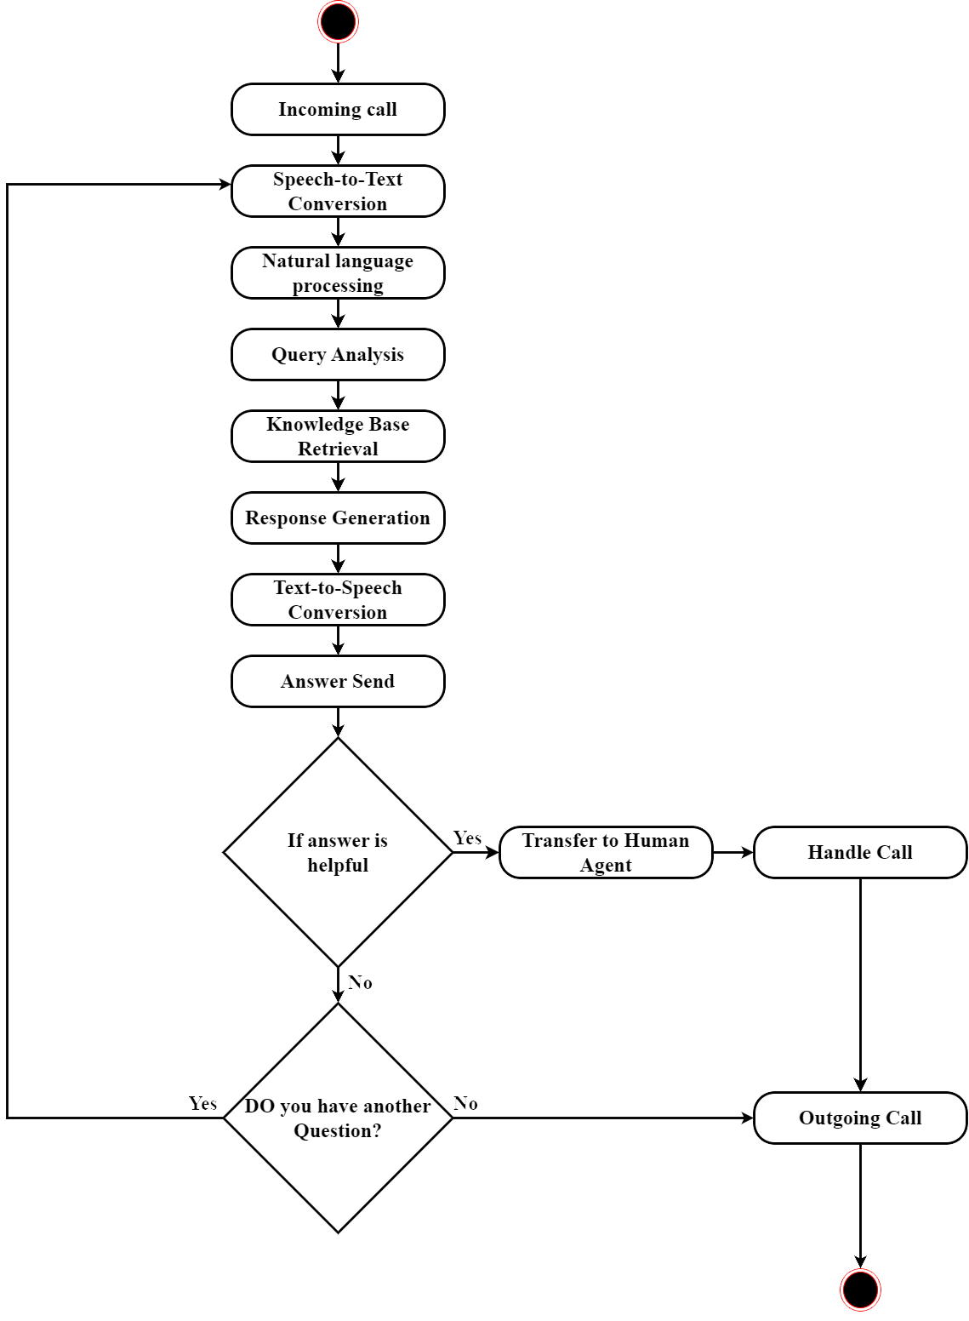

Figure 13

### 4.3.2 UseCase Diagram

A use case is a detailed description of how a system interacts with an external entity (such as a user or another system) to accomplish a specific goal. Use cases are commonly used in software development to capture and document system requirements from a user's perspective. They provide a clear understanding of the system's functionalities and help guide developers in building software that meets user needs.

The main actors:

1. Customer
2. Administrator
3. Human agent
4. AI system

The customer/End user interactions are specified in two use cases:

1. Placing a call for the call center
2. Receiving assistance for his questions or queries

Administrator role:

1. Can mange AI system.
2. Configure agent.
3. generating reports

Human agent role:

1. Answering calls from customers who had questions the AI was unable to answer.
2. Handling call after AI cannot handle the customer queries.

AI agent role:

1. Can handle and receive calls by supporting customer through the dataset knowledge.
2. Transfer calls to the human agent when the customer problem is not solved by itself.
3. Analise call by making the main AI models successful work.

Conclusion:  
The customer initiates contact with the call center, where the AI agent promptly manages the call, addressing all customer inquiries by referencing a meticulously trained dataset for solutions. Responses are swiftly delivered to the customer, ensuring minimal wait times. In cases where the AI encounters challenges in addressing the call or resolving customer queries, seamless transfer to a human agent is facilitated to ensure comprehensive assistance and resolution for the customer.

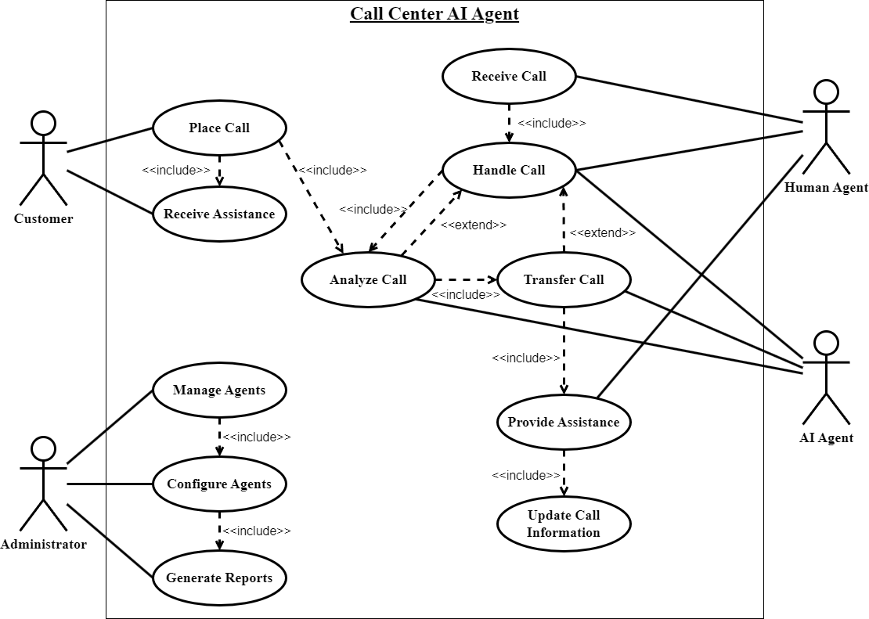

Figure 14

### 4.3.3 Sequence Diagram

A sequence diagram, a cornerstone of the Unified Modeling Language (UML), portrays the intricate interplay among objects within a targeted scenario or use case. This diagram encapsulates the chronological flow of messages exchanged between distinct entities, whether they are objects or actors, delineating the temporal progression of interactions.

Scenario:

In this scenario, the customer initiates contact with the call center by placing a call. The AI agent promptly responds to the call and adeptly addresses the customer's query.

The sequence:

The sequence unfolds as follows: The end user initiates a call, which is promptly answered by the AI agent. Subsequently, the AI agent conducts a comprehensive analysis of the customer's speech by converting it into text and processing it through the NLP (natural language processing) model. Following this, the AI agent verifies the query's solvability through dataset evaluation, initiating the generation of a response. Upon formulating the response in text format, it is seamlessly converted into speech and relayed back to the customer. In cases where the AI is unable to handle the call, it efficiently transfers the call to a human agent for further assistance.

### 4.3.4 Entity Relationship Diagram

Figure 15

#### 

Figure 16

# Chapter 5 – Design

Engineering design is a process of devising a system, component, or process to meet desired needs and specifications within constraints. It is an iterative, creative, decision-making process in which the basic sciences, mathematics, and engineering sciences are applied to convert resources into solutions. Engineering design involves identifying opportunities, developing requirements, performing analysis and synthesis, generating multiple solutions, evaluating solutions against requirements, considering risks, and making trade-offs, to obtain a high-quality solution under the given circumstances. For illustrative purposes only, examples of constraints include accessibility, aesthetics, codes, constructability, cost, ergonomics, extensibility, functionality, interoperability, legal considerations, maintainability, manufacturability, marketability, policy, regulations, schedule, standards, sustainability, or usability.

## 5.1 UML Diagrams

TBD

## 5.2 Technologies and Tools Used

TBD

## 5.3 Results and Discussion

TBD

# Chapter 6 – Implementation

## 6.1 Implementation Environment

TBD

## 6.2 Add sections as required

TBD

## 6.3 Results and Discussion

TBD

# Chapter 7 – Testing

# Chapter 8 – Conclusion and Future Work

# Appendix A – Software Requirements Specifications IEEE 830

**Chapter 1 – Introduction**

* 1. ***Purpose***

AI system's main objective is to automate customer support interactions, overseeing incoming questions and providing accurate and timely responses. This reduces the need for human operators to address routine inquiries, allowing them to focus on more complex tasks. The system efficiently processes and addresses a wide range of customer inquiries by utilizing a dataset as its knowledge base. It can manage a high volume of inquiries simultaneously, ensuring prompt responses without extended wait times. The AI system aims to deliver accurate and consistent responses, relying on a comprehensive and up-to-date dataset for reliable information. It possesses robust natural language understanding capabilities, accurately comprehending and interpreting customer queries, regardless of variations in language or tone. The system continually learns from customer interactions, improving its performance and incorporating latest information to meet evolving customer needs. It seamlessly integrates with the call center infrastructure, supporting various communication channels such as phone calls, chat, or email. Additionally, the system may provide reporting and analytics features, offering insights into customer interactions, satisfaction levels, The AI system's primary purpose is to automate customer support interactions, effectively overseeing incoming questions and providing precise and timely responses. This reduces the reliance on human operators for routine inquiries, allowing them to focus on more complex or specialized tasks. The system excels at efficiently processing and addressing a wide range of customer inquiries by leveraging a dataset as its knowledge base. It is designed to manage a high volume of inquiries simultaneously, ensuring prompt responses and minimizing wait times. The AI system strives to deliver accurate and consistent responses, drawing upon a comprehensive and up-to-date dataset to ensure the information it provides is correct. It possesses robust natural language understanding capabilities, enabling it to accurately comprehend and interpret customer queries, even when they are expressed differently or vary in language or tone. The system incorporates mechanisms for continuous learning and improvement, benefiting from customer interactions to enhance its performance over time. It can adapt and update its dataset to incorporate latest information and cater to evolving customer needs. Seamless integration with the call center infrastructure is a key feature, allowing the system to interact with customers through various communication channels, including phone calls, chat, or email. The AI system may also offer reporting and analytics functionalities, providing insights into customer interactions, frequently asked questions, satisfaction levels, and performance metrics. These insights assist call center managers in making informed decisions to optimize processes and improve customer service.

***1.2 Document Conventions***

|  |  |  |  |
| --- | --- | --- | --- |
|  | Font name | Font size | Style |
| Titles | Times | 14 | Bold |
| Subheadings | Times | 12 | Bold-Italic |
| Sub-subheadings | Times | 11 | Italic |
| Sub-sub-subheadings | Arial | 11 | Italic |
| Body | Arial | 11 | Normal |

***1.3 Intended Audience and Reading Suggestions***

The AI agent project is expected to attract the interest of various individuals and groups. Project stakeholders, including project managers, developers, data scientists, AI experts, and system administrators, would naturally be interested due to their direct involvement in the project's development and implementation. Call center management, responsible for overseeing operations, would be intrigued by the potential benefits the AI agent brings to customer support and operational efficiency. Call center operators, who oversee customer inquiries daily, would be keen to learn how the AI agent can assist them in streamlining processes and enhancing their performance. The IT department, responsible for integrating and maintaining the AI agent within the existing call center infrastructure, would have a personal stake in the project's technical aspects. Executives and decision-makers would be interested in understanding the project's potential impact on customer service, operational efficiency, and cost savings. Customers themselves would benefit from the improved response times, accurate information, and positive customer support experience that the AI agent aims to deliver. Additionally, industry professionals, researchers, and academics in the fields of AI, natural language processing, and customer support may find the project's methodologies and outcomes valuable for their own work and research.

***1.4 Product Scope***

The scope of the AI agent project encompasses various aspects that aim to enhance customer support and operational efficiency in the context of a call center. The project focuses on developing an AI-powered agent that can assist call center operators in handling customer inquiries and providing support. The AI agent will be designed to understand natural language, analyze customer requests, and generate appropriate responses or recommendations. The scope includes integrating the AI agent into the existing call center infrastructure, ensuring compatibility and seamless interaction with other systems and tools. The project also involves defining and implementing performance metrics to assess the effectiveness of the AI agent, such as response times, accuracy rates, and customer satisfaction. Data privacy and security considerations will be an integral part of the project scope, ensuring that customer information is managed securely and in compliance with relevant regulations. The scope may also involve conducting pilot tests or trials to validate the AI agent's performance and gather user feedback for further improvements. Overall, the scope of the AI agent project encompasses the development, integration, evaluation, and optimization of an AI-powered solution to enhance customer support and operational efficiency in the call center environment.

**Chapter 2 – Overall Description**

***2.1 Product Perspective***

The origin of this product could stem from the increasing demand for more efficient and effective customer support solutions. As businesses grow and customer interactions rise, there is a need to streamline processes and handle inquiries in a timely and accurate manner. The idea of incorporating AI into call center operations arose from the desire to leverage technology to automate repetitive tasks, analyze large volumes of customer data, and provide quicker, more accurate responses.

The decision to develop this AI agent may have been influenced by advancements in natural language processing and machine learning, making it feasible to create a system that can understand and respond to the nuances of human language. Additionally, the focus on data privacy and security suggests a conscientious approach to ensure that the handling of customer information aligns with ethical and legal standards.

***2.2 Product Functions***

The AI agent project functions as a comprehensive initiative aimed at revolutionizing customer support and operational efficiency within a call center environment. At its core, the AI agent boasts Natural Language Understanding (NLU) capabilities, enabling it to grasp and interpret customer inquiries in a manner akin to human operators. Beyond mere comprehension, the AI agent excels in generating contextually appropriate responses or recommendations, thereby providing valuable assistance to users. Integration into the existing call center infrastructure is a pivotal aspect, ensuring a seamless interaction with other tools and systems utilized by operators. Performance evaluation constitutes a crucial function, with the project involving the definition and implementation of key metrics such as response times, accuracy rates, and customer satisfaction indicators. Notably, the project places a strong emphasis on data privacy and security, guaranteeing the secure handling of customer information in compliance with relevant regulations. Pilot tests or trials serve to validate the AI agent's performance in real-world scenarios, with user feedback instrumental for further refinements. The project functions culminate in a commitment to continuous optimization, fine-tuning algorithms, and responses to enhance overall efficiency and effectiveness.

***2.3 User Classes and Characteristics***

Various stakeholders in the customer service and call center industry would find value in using the described AI agent product. Firstly, call center operators and customer support teams stand to benefit significantly, as the AI agent can assist them in handling and responding to a high volume of customer inquiries efficiently. The product is tailored to enhance the operational efficiency of these teams by automating routine tasks and providing quick and accurate responses.

Companies and businesses with call centers would also need this product, as it offers a solution to improve overall customer satisfaction and streamline their support processes. The AI agent's integration into existing call center infrastructure ensures a smooth implementation for organizations seeking to modernize their customer service operations.

Additionally, customers themselves would indirectly benefit from the product, experiencing faster response times and more accurate assistance when reaching out to a call center for support. The improved efficiency of the call center operations translates to a better customer experience, which is a key priority for businesses in various industries.

***2.4 Operating Environment***

The AI agent is tailored to function within the dynamic setting of a call center, where it interacts with a diverse range of hardware and software components. Concerning hardware, the AI agent is designed to be flexible, accommodating different configurations commonly found in call centers, including servers, networking equipment, and operator workstations. In terms of operating systems, the AI agent is adaptable to various platforms such as Windows, Linux, or others, ensuring compatibility with different versions prevalent in call center IT environments.

Coexistence is a key consideration, and the AI agent is engineered to seamlessly integrate with existing software components and applications within the call center. This includes compatibility with customer relationship management (CRM) systems, ticketing platforms, communication tools, and any proprietary software utilized by the call center. The goal is to enhance operational processes without causing disruptions, fostering a harmonious integration.

***2.5*** ***Design and Implementation Constraints***

One significant constraint lies in ensuring compatibility with existing legacy systems within the call center infrastructure, necessitating thoughtful solutions for seamless integration. Scalability presents another challenge, requiring the AI agent to oversee potential increases in call center workloads efficiently without compromising performance. Regulatory compliance, especially with data privacy laws, imposes constraints on how customer data is overseen and stored. Limited availability and quality of training data pose challenges, urging the project to develop effective learning strategies with constrained datasets. The potential for operational downtime during the implementation phase must be minimized to avoid disruptions. Achieving user acceptance by call center operators is essential, placing constraints on the design to ensure a user-friendly interface and comprehensive training. Cost constraints and the need for a balanced approach between functionality and affordability must be navigated. Dependencies on specific technologies and frameworks pose additional constraints that demand careful management. Meeting response time requirements is critical, influencing the design of algorithms and infrastructure. Finally, implementing robust security measures introduces constraints related to system performance and operational complexity. Addressing these constraints requires meticulous planning, thorough testing, and collaboration among stakeholders to ensure the successful integration and operation of the AI agent in the call center environment.

***2.6 User Documentation***

*2.6.1 Introduction and Overview*

This guide aims to provide comprehensive instructions and guidance for call center operators interacting with the AI agent. The AI agent is designed to assist in handling customer inquiries and optimizing call center operations.

*2.6.2 User Guide*

Accessing the AI Agent: To initiate interaction with the AI agent, log in to the designated platform using your credentials provided by the system administrator.

*2.6.3 Interface Explanation*

The graphical interface displays input fields for queries and outputs responses in a conversational format. A chat-style interface allows for seamless interaction with the AI agent, providing a user-friendly experience.

*2.6.4 Use Cases and Scenarios*

Customer Support:

Scenario: A customer calls in with a product inquiry or issue.

Use Case: The AI model understands natural language queries, provides relevant information, troubleshoots common problems, and, if necessary, seamlessly transfers the call to a human agent for more complex issues.

Appointment Scheduling:

Scenario: A user wants to schedule an appointment or book a service.

Use Case: The AI system can access the calendar, check availability, and schedule appointments, providing confirmation details to the caller. It can also handle cancellations and rescheduling.

Surveys and Feedback:

Scenario: After a customer interaction, the system asks for feedback.

Use Case: The AI can conduct post-call surveys to gather feedback on customer satisfaction. It analyzes the responses and identifies areas for improvement, helping the company enhance its services.

*2.6.5 FAQs and Troubleshooting*

Frequently Asked Questions:

|  |  |
| --- | --- |
| Question | Answer |
| Can the AI understand multiple languages? | Yes, the AI is designed to support multiple languages. You can communicate with it in the language you are most comfortable with. |
| How do I ensure the AI understands my query correctly? | Speak or type your question clearly and concisely. If the AI needs clarification, it will prompt you for more information. |

Troubleshooting:

|  |  |
| --- | --- |
| Issue | Resolution |
| Inaccurate Information Provided by AI | Ensure that your query is clear and specific. If the issue persists, the AI might need additional training data. Please report the inaccuracy to the technical support team. |
| Unexpected Responses from the AI | Review your query for clarity. If the problem persists, check for updates to the AI model. If the issue continues, contact technical support for assistance. |
| Difficulty Connecting to the AI | Check your internet connection and firewall settings. If the problem persists, contact technical support for further assistance. |

*2.6.6 Best Practices and Tips*

Provide Feedback: Offer feedback on the AI's responses. If the answer is accurate, let the system know. If there's a misunderstanding, provide corrective feedback to help improve future interactions.

Be Patient: Allow the AI a moment to process and respond. In complex inquiries, it might take a bit longer to provide a comprehensive answer.

***2.7 Assumption and Dependencies***

It assumes the presence of ample and varied training data for effective learning, contingent on the quality and accessibility of such data. A consistent and dependable internet connection is presumed for smooth communication between the AI agent and other call center systems, with dependencies on the state of network infrastructure considered. User acceptance is presumed, necessitating the willingness of call center operators to embrace AI assistance, and dependencies exist on effective training and collaboration strategies. The assumption of compliance with data privacy and security regulations hinges on staying informed about regulatory changes and adjusting the AI agent accordingly. Successful integration with existing call center systems, the stability of operating system environments, and the availability of adequate resources for implementation are all presumed, with dependencies on factors like compatibility, cooperation, and resource management. Assuming a steady influx of user feedback for continual improvement relies on establishing effective mechanisms for collecting and analyzing feedback. Adherence to the project timeline is presumed, with dependencies on robust project management and strategies to mitigate potential delays. Lastly, the assumption of stable external APIs and services is contingent on monitoring and adapting to any changes or disruptions. Recognizing and managing these assumptions and dependencies is crucial for effective project planning, risk mitigation, and the attainment of the AI agent's objectives in the call center environment, with regular reassessment recommended throughout the project lifecycle.

**Chapter 3 – External Interface Requirements**

***3.1 User Interfaces***

The specific design elements and layout of the AI call center's user interface are still under development and will be finalized during the subsequent phases of this project. As of the current documentation, certain details regarding the placement of navigation elements, visual design components, and other user interface aspects are To Be Determined (TBD).

***3.2*** ***Hardware Interfaces***

In the context of implementing an AI agent within a call center, the hardware interface is a critical component encompassing the physical infrastructure necessary for the AI system's operation. It involves ensuring compatibility with the diverse workstation configurations utilized by call center operators, accommodating various operating systems and hardware specifications. Additionally, the hardware interface includes the server infrastructure essential for hosting and executing the AI algorithms efficiently, with considerations for scalability and performance to manage varying workloads effectively. Seamless communication between different components of the AI system and other call center systems relies on networking equipment such as routers, switches, and network infrastructure, ensuring stable connectivity. Integration with peripheral devices like headsets or microphones used by operators might also be part of the interface, necessitating compatibility and interfaces for these devices. Security hardware, including firewalls or encryption devices, forms a crucial part of the hardware interface to protect data and comply with privacy regulations. In mission-critical environments, redundancy and failover systems become integral, comprising backup servers and redundant networking equipment for system resilience. Furthermore, considerations for scalability, upgradability, physical installation, cabling, and ongoing maintenance are essential aspects addressed within the hardware interface to support the AI system's smooth operation within the call center environment.

***3.3 Software Interfaces***

The software interface for the AI agent project within the call center environment plays a pivotal role in facilitating interactions between the AI system and the array of software components. Central to this interface is the provision of a user-friendly interface for call center operators, enabling smooth interactions with the AI agent through graphical or command-line interfaces. Seamless integration with existing call center software, such as CRM systems, ticketing platforms, and communication tools, stands as a critical aspect ensured by the software interface. This integration facilitates data exchange and interaction between the AI agent and these integral systems. The interface relies on application programming interfaces (APIs) and industry-standard protocols to enable effective communication and data exchange between different software components. Moreover, the software interface encompasses components for data processing, analytics, and reporting, allowing for insights into performance metrics like response times and customer satisfaction. Additionally, mechanisms for real-time feedback collection, security protocols aligned with data privacy regulations, monitoring tools, adaptability for updates, error handling, and logging are integral parts of this interface. These collectively ensure efficient operation, integration, and continuous improvement of the AI agent within the call center's software ecosystem.

***3.4*** ***Communications Interfaces***

The communication interface for the AI agent project within a call center environment serves as the essential conduit enabling interactions between the AI system, call center operators, and various communication channels. This interface facilitates diverse channels for operator interaction, including chat interfaces, voice-based systems, or a combination of both, offering flexible means for operators to engage with the AI agent. Seamless integration with existing call center communication systems, encompassing phone lines, VoIP services, or messaging platforms, ensures the AI agent communicates effectively with both customers and operators through established channels. Interoperability protocols are vital components, enabling standardized data exchange and connections between the AI agent and different communication platforms. Multi-platform support ensures compatibility across devices and platforms, enhancing accessibility for users. Real-time communication capabilities are crucial, ensuring prompt responses to queries and efficient customer support. Scalability and reliability are key considerations, allowing the interface to adapt to varying communication loads while ensuring consistent and uninterrupted communication. Feedback channels embedded within the interface facilitate the collection of user responses, fostering continuous improvement. Security measures, including secure communication protocols and encryption mechanisms, safeguard sensitive information exchanged during interactions, ensuring compliance with data privacy regulations. Lastly, adaptability to new communication technologies ensures the interface remains future-ready and can incorporate emerging advancements in communication methods, ensuring ongoing effectiveness and relevance.

**Chapter 4 – System Features**

The call center operator AI agent comprises crucial system features, each contributing uniquely to its smooth operation. Ranging from its prowess in understanding natural language to retaining conversation context, these functions are essential. The Recommendation Engine tailors solutions, while Multi-Channel Interaction ensures seamless communication. Personalization and User Profiles customize experiences, while Escalation and Human Handover aid transitions. Feedback Mechanisms and Performance Analytics drive improvement, while Security and Compliance ensure data integrity. Scalability and Reliability promise consistent performance. Together, these features define the AI agent's capabilities, enhancing operational efficiency and customer interactions in the call center environment.

***4.1 Natural Language Processing (NLP)***

*4.1.1 Description and Priority*

Description: The Natural Language Processing (NLP) feature enables the AI call center agent to comprehend and interpret natural language input from users. This includes understanding user queries, extracting relevant information, and providing appropriate responses.

Priority: High priority. This feature is crucial for enhancing the user experience and ensuring effective communication between users and the AI call center agent.

*4.1.2 Stimulus/Response Sequences*

Stimulus: User initiates a conversation with the AI call center agent by providing a natural language query.  
Response: AI agent analyzes the input using NLP techniques.  
The agent extracts Question and context from the user's query.  
System responds with appropriate actions or information based on the understanding of the user's input.

*4.1.3 Functional Requirements*

REQ-1: The AI agent must implement state-of-the-art NLP algorithms for natural language understanding.  
REQ-2: The system should support multiple languages to accommodate users with diverse language preferences.  
REQ-3: NLP processing should include intent recognition to identify the user's purpose or goal.  
REQ-4: Entity extraction capability is required to identify and extract specific pieces of information from user input.  
REQ-5: The system should maintain context across user interactions to ensure coherent and context-aware responses.  
REQ-6: Natural language understanding should consider variations in user input, including synonyms and colloquial expressions.  
REQ-7: Regular updates and improvements to the NLP models should be incorporated to adapt to evolving language patterns.

***4.2 Knowledge Base Integration***

*4.2.1 Description and Priority*

Description: The Knowledge Base Integration feature involves integrating the AI call center agent with a knowledge base or database. This integration aims to enable the agent to retrieve relevant information and provide informed responses to user queries, enhancing the overall effectiveness of the AI system.  
Priority: High priority. This feature is crucial for ensuring that the AI call center agent can provide accurate and up-to-date information to users, thereby improving the quality of customer interactions.

*4.2.2 Stimulus/Response Sequences*

Stimulus: User asks a question or requests information from the AI call center agent.  
Response: The AI agent queries the integrated knowledge base or database to retrieve relevant information.  
The system analyzes the retrieved data and provides a response based on the knowledge base content.

*4.2.3 Functional Requirements*

REQ-1: The AI system must integrate with a knowledge base or database containing relevant information for user queries.   
REQ-2: The integration should support efficient and fast retrieval of information from the knowledge base.  
REQ-3: Integration should include mechanisms to update the knowledge base regularly to ensure the information is current and accurate.  
REQ-4: The AI agent should be able to understand and interpret user queries in a way that allows it to effectively search the knowledge base for relevant information.  
REQ-5: The system must handle cases where the knowledge base does not contain relevant information, providing appropriate responses to users.  
REQ-6: Security measures should be implemented to protect sensitive information stored in the knowledge base.

***4.3 Escalation to Human Agents***

*4.3.1 Description and Priority*

Description: The Escalation to Human Agents feature enables the AI call center agent to escalate complex issues to human agents when necessary. This includes providing the capability for transferring relevant context and information seamlessly to ensure a smooth transition from AI assistance to human intervention.  
Priority: High priority. This feature is crucial for handling situations where the AI agent may encounter complex issues beyond its capability, ensuring that users receive appropriate assistance from human agents.

*4.3.2 Stimulus/Response Sequences*

Stimulus: The AI agent identifies a query or situation that exceeds its current capabilities or requires human intervention.  
Response: The AI system initiates an escalation process, transferring relevant context and information to human agents.  
The system informs the user that the query has been escalated and provides appropriate instructions or confirmation.

*4.3.3 Functional Requirements*

REQ-1: The AI system should have predefined criteria for identifying situations that require escalation to human agents.  
REQ-2: Seamless transfer of context and relevant information from the AI agent to human agents must be supported.  
REQ-3: The system should maintain a log of interactions to provide human agents with historical context when taking over a conversation.  
REQ-4: Escalation should occur with minimal disruption to the user, ensuring a smooth transition between AI and human assistance.  
REQ-5: Human agents receiving escalations should be provided with sufficient information to understand the user's query and the AI agent's responses.  
REQ-6: The system must allow human agents to intervene, take over the conversation, and respond appropriately to user queries.

***4.4 User Feedback Mechanism***

*4.4.1 Description and Priority*

Description: The User Feedback Mechanism feature involves implementing a feedback system to collect user feedback and enhance the effectiveness of the AI call center agent. This includes gathering insights from users to identify areas for improvement and ensuring continuous refinement of the AI system.  
Priority: Medium priority. While important for ongoing improvement, this feature is not as critical as some of the core functionalities. However, it contributes to the iterative enhancement of the AI agent's performance and user satisfaction.

*4.4.2 Stimulus/Response Sequences*

Stimulus: User completes an interaction with the AI call center agent.  
Response: The system prompts the user to provide feedback on their experience with the AI agent.

*4.4.3 Functional Requirements*

REQ-1: The AI system should include a feedback mechanism presented to users at the end of interactions.  
REQ-2: The feedback system should allow users to rate their overall experience with the AI agent.  
REQ-3: Users should have the option to provide specific comments or suggestions for improvement.  
REQ-4: Collected feedback data should be stored for analysis and reporting.  
REQ-5: Feedback data should be anonymized to ensure user privacy.  
REQ-6: The AI system must use the collected feedback to identify trends and areas for improvement.  
REQ-7: Periodic reports or summaries of user feedback should be generated for analysis by development teams.

**Chapter 5 – Other Non-Functional Requirements**

***5.1***  ***Performance Requirements***

Performance requirements for a call center operator AI agent encompass various aspects ensuring its effective functionality and responsiveness:

*5.1.1 Response Time*  
The system should provide prompt responses to queries, aiming for an average response time of under 3 seconds for standard inquiries.

*5.1.2 Throughput*  
It should manage a high throughput of concurrent interactions, supporting at least one hundred simultaneous conversations without performance degradation.

*5.1.3 Accuracy Rates*  
Achieve an accuracy rate of over 95% in query interpretations and recommendations provided by the AI agent

*5.1.4 Availability*  
Maintain high availability, aiming for a system uptime of 99.9% to ensure uninterrupted service during operational hours.

*5.1.5 Scalability*  
Scale dynamically to accommodate fluctuations in query loads, seamlessly managing a 50% increase in traffic during peak times.

*5.1.6 Load Testing*  
Regularly conduct load testing to evaluate system performance under heavy loads, ensuring consistent and reliable operation.

*5.1.7 Resource Utilization*  
Optimize resource utilization, aiming for efficient use of computational resources to minimize latency and maximize responsiveness.

*5.1.8 Feedback Incorporation*  
integrate operator feedback into system updates promptly, ensuring continual improvements without disruptions to service.

***5.2 Safety Requirements***

Safety requirements for a call center operator AI agent primarily focus on ensuring data security, user privacy, and compliance with regulatory standards:

*5.2.1 Data Encryption*  
Implement end-to-end encryption for all user interactions and stored data to prevent unauthorized access and ensure data confidentiality.

*5.2.2 Access Controls*  
Utilize robust access control mechanisms to restrict system access based on roles and permissions, preventing unauthorized usage or data breaches.

*5.2.3 Compliance Adherence*  
Ensure compliance with relevant data protection regulations, safeguarding user information and interactions.

*5.2.4 Secure Storage*  
Store and manage user data in secure, encrypted databases or storage systems, preventing data leaks or unauthorized retrieval.

*5.2.5 Regular Audits*  
Conduct periodic security audits and assessments to identify vulnerabilities and ensure continuous adherence to safety protocols.

*5.2.6 User Data Privacy*  
Prioritize user data privacy, providing transparent policies on data collection, storage, and usage, obtaining explicit consent from users where necessary.

*5.2.7 Incident Response Plan*  
Develop and maintain a comprehensive incident response plan to address and mitigate any security breaches or data incidents promptly.

*5.2.8 Training and Awareness*  
Provide regular training to personnel managing the AI system, emphasizing data security protocols and best practices to mitigate risks.

*5.2.9 Security Updates*  
Ensure timely application of security patches and updates to all system components to address vulnerabilities and strengthen system security.

*5.2.10 Regulatory Reporting*  
Maintain records and documentation to facilitate regulatory reporting and compliance verification, ensuring transparency and accountability.

***5.3 Security Requirements***

Security requirements for a call center operator AI agent entail various measures to safeguard data integrity, prevent unauthorized access, and ensure compliance:

*5.3.1 Data Encryption*  
Employ robust encryption mechanisms (e.g., AES 256-bit encryption) for both data in transit and at rest within the system to prevent unauthorized access or data breaches.

*5.3.2 Access Control*  
Implement role-based access control (RBAC) to restrict system access based on user roles, ensuring that only authorized personnel can perform specific actions or access sensitive data.

*5.3.3 Authentication and Authorization*  
Utilize multi-factor authentication (MFA) for user authentication and ensure granular authorization controls to manage user privileges within the system.

*5.3.4 Secure Communication Protocols*  
Enforce the use of secure communication protocols to protect data transmitted between the AI agent, users, and external systems.

*5.3.5 Logging and Monitoring*  
Implement comprehensive logging mechanisms to record system activities and user interactions, enabling real-time monitoring and detection of suspicious activities.

*5.3.6 Regular Security Audits*  
Conduct periodic security audits and vulnerability assessments to identify and mitigate potential security loopholes or weaknesses in the system.

*5.3.7 Incident Response Plan*  
Develop and regularly update an incident response plan outlining protocols for responding to security incidents, including containment, investigation, and recovery procedures.

*5.3.8 Data Masking and Anonymization*  
Apply data masking or anonymization techniques to obscure sensitive information, minimizing the risk of exposing personally identifiable data.

*5.3.9 Regular Software Updates*  
Ensure timely application of security patches and updates to all software components to address known vulnerabilities and maintain a secure system environment.

*5.3.10 Regulatory Compliance*  
Adhere to relevant industry standards and regulatory requirements concerning data privacy and security, ensuring compliance in all system operations.

***5.4 Software Quality Attributes***

Several quality attributes are crucial for the success and effectiveness of a call center operator AI agent:

*5.4.1 Accuracy*  
The AI agent must provide precise and correct responses to customer inquiries, ensuring high accuracy in interpreting queries and delivering relevant information or solutions.

*5.4.2 Reliability*Ensuring consistent performance and availability is vital. The system should reliably function without interruptions, minimizing downtime and ensuring dependable service.

*5.4.3 Scalability*  
The ability to oversee varying workloads efficiently, scaling up to accommodate increased user demands during peak times without compromising performance or responsiveness.

*5.4.4 Usability*  
A user-friendly interface and intuitive interaction design are essential for operators, ensuring ease of use, reducing training time, and facilitating efficient utilization of the AI agent.

*5.4.5 Maintainability*  
The system should be easy to maintain and update, allowing for swift incorporation of improvements, bug fixes, and adaptations to changing requirements or technologies.

*5.4.6 Security*Ensuring robust data security measures, access controls, encryption, and compliance with privacy regulations to safeguard sensitive user information and interactions.

*5.4.7 Performance*  
Meeting defined performance metrics such as response times, throughput, and accuracy rates consistently to ensure efficient handling of customer queries.

*5.4.8 Adaptability*  
The AI agent should possess adaptive capabilities, learning from user interactions and evolving to improve its understanding and responses over time.

*5.4.9 Interoperability*  
Ability to integrate seamlessly with various call center systems, databases, and tools, allowing for smooth data exchange and communication across platforms.

***5.5 Business Rules***

Business rules for a call center operator AI agent encompass specific guidelines dictating its operations and conduct within the business framework. These rules define response time standards tailored to different query types, ensuring timely customer support. Criteria are established for query escalation to human agents based on complexity or customer preference. Protocols regarding data privacy and compliance with regulations govern how customer information is managed and stored. The agent's supported languages, compliance checks, and integration of operator feedback are also outlined. Quality assurance metrics and scripting guidelines maintain service consistency and professionalism. Procedures for addressing customer complaints, fostering continuous learning, and adaptation mechanisms for ongoing improvement complete the comprehensive set of rules guiding the AI agent's behavior and interactions within the call center ecosystem.

**Chapter 6 – Other Requirements**

***6.1 Error Handling and Recovery***  
The system should gracefully oversee errors, providing clear error messages and recovery mechanisms to minimize service disruption and data loss.

***6.2 Auditing and Logging***  
Maintain comprehensive logs of system activities, user interactions, and changes made within the system for auditing, troubleshooting, and compliance purposes.

***6.3 User Training and Support***  
Provide comprehensive training materials, guides, and support resources for call center operators to effectively utilize and troubleshoot the AI agent.

***6.4 Localization and Internationalization***  
Support localization to adapt the AI agent's interface, responses, and content to different regions or languages to enhance user experience for diverse customer bases.

***6.5 Regulatory Compliance Reporting***  
Generate reports or logs that demonstrate compliance with various regulatory standards, enabling easy auditing and verification.

***6.6 System Performance Under Stress***  
Conduct stress testing to ensure the system maintains acceptable performance levels even under extreme load conditions or unexpected spikes in user interactions.

***6.7 Response Consistency***  
Ensure consistency in responses and behaviors across different versions or instances of the AI agent deployed in various call centers or locations.

# Appendix B – Software Test Plan IEEE 829

# Chapter 1 – Scope

## 1.1 Purpose of the Test Plan

The purpose of this test plan is to ensure that the AI agent call center project meets its objectives effectively and efficiently. By systematically testing the AI agents powered by Llama 2 chat, BERT, and T5, we aim to:  
Validate the performance, accuracy, and reliability of the AI agents in various scenarios.  
Identify and address any issues or limitations in the AI models or their integration with the call center platform.  
Optimize the configuration and usage of AI models to maximize their impact on call center operations.  
Provide stakeholders with confidence in the functionality and readiness of the AI agent call center solution for deployment.

## 1.2 Features and Functionalities to be Tested

1.2.1 Natural Language Understanding (NLU)  
Evaluate the AI agents' ability to comprehend and interpret natural language queries from customers accurately.

1.2.2 Response Generation  
Assess the AI agents' capability to generate relevant and contextually appropriate responses to customer queries.

1.2.3 Multimodal Support  
Test the AI agents' proficiency in handling various communication channels, including text-based chat and voice interactions.

1.2.4 Integration with Call Center Systems  
Ensure seamless integration with existing call center infrastructure, including CRM systems, ticketing platforms, and knowledge bases.

1.2.5 Scalability and Performance  
Evaluate the scalability of the AI agents to handle a large volume of concurrent interactions while maintaining performance standards.

1.2.6 Error Handling  
Test the AI agents' ability to gracefully handle errors, misunderstandings, and ambiguous queries to provide helpful and accurate assistance.

1.2.7 Security and Privacy  
Verify that the AI agents adhere to security protocols and privacy regulations, safeguarding sensitive customer data during interactions.

## 1.3 Inclusions

1.3.1 Functional Testing  
Comprehensive testing of all functional aspects of the AI agents, including NLU, response generation, and integration with call center systems.

1.3.2 Performance Testing  
Evaluating the scalability, response time, and resource utilization of the AI agents under varying load conditions.

1.3.3 Integration Testing  
Ensuring seamless integration with existing call center infrastructure and other third-party systems.

1.3.4 Usability Testing  
Assessing the user-friendliness and effectiveness of the AI agents from both customer and agent perspectives.

1.3.5 Security Testing  
Verifying compliance with security standards and conducting vulnerability assessments to identify potential risks.

1.3.6 Compatibility Testing  
Testing the compatibility of the AI agents with different devices, browsers, and communication channels.

## 1.4 Exclusions

1.4.1 Hardware Testing  
Excluding testing related to the hardware infrastructure, such as servers, network devices, and telephony systems.

1.4.2 Non-AI Features  
Excluding testing of features not directly related to the AI agents, such as administrative tools, reporting functionalities, and agent training modules.

1.4.3 Third-Party Service Dependencies  
Excluding testing of third-party services or APIs unless essential for the functioning of the AI agents.

# Chapter 2 – Test Plan

2.1 PurposeThe primary aim of developing the Test Plan for the AI Call Center Agent is to furnish stakeholders, project teams, and testing personnel with a detailed and comprehensive document outlining the testing approach, strategies, and resources essential for guaranteeing the quality and reliability of the AI-driven call center system. This Test Plan serves as a roadmap, aligning testing efforts with project goals and ensuring systematic evaluation of the system's performance.

2.2 OutlineThe Test Plan is structured to cover various critical aspects, ensuring a holistic understanding of the testing process:

2.2.1 ScopeClearly defining the boundaries of testing activities, specifying what functionalities and components will be subjected to testing. This ensures a focused approach, addressing key aspects of the AI Call Center Agent.

2.2.2 ObjectivesOutlining the specific goals and targets that testing aims to achieve. These objectives serve as benchmarks, aligning testing efforts with the broader project objectives and ensuring that the system meets predefined standards.

2.2.3 Testing ApproachDetailing the methodologies, techniques, and approaches that will be employed during testing. This section provides insights into the overall strategy, helping stakeholders understand how the testing process will unfold.

2.2.4 Test Deliverables  
Enumerating the expected outputs and documentation that will be generated as a result of the testing activities. This includes reports, logs, and any other artifacts that provide insights into the testing process and outcomes.

2.2.5 SchedulePresenting a timeline that outlines when testing activities will take place. This includes milestones, deadlines, and dependencies to ensure timely completion of testing phases and alignment with the project schedule.

2.2.6 Resource AllocationSpecifying the personnel, tools, and equipment required for testing. Proper allocation of resources ensures that the testing team is adequately equipped to carry out their responsibilities efficiently.

2.2.7 Roles and ResponsibilitiesClearly defining the roles and responsibilities of team members involved in the testing process. This section ensures that each team member understands their specific contributions to the testing effort.

2.2.8 Risks and Mitigation StrategiesIdentifying potential risks that may impact the testing process and outlining strategies to mitigate these risks. This proactive approach helps in minimizing the impact of unforeseen challenges on the testing activities.

# Chapter 3 – Test Design Specification

## 3.1 Purpose

The fundamental purpose of the Test Design Specification is to provide a meticulous and comprehensive account of the testing architecture and design strategy devised for the AI Call Center Agent. This document serves as a blueprint, elucidating how various components and functionalities within the system will be systematically and rigorously tested to meet the pre-established requirements. The Test Design Specification is instrumental in guiding testing efforts towards ensuring the robustness and reliability of the AI-driven call center system.

## 3.2 Outline

The Test Design Specification is structured to encompass the following key components, providing a well-organized framework for designing and executing effective testing:

### 3.2.1 Testing Objectives

Clearly articulating the specific goals and objectives that the testing process aims to achieve. These objectives serve as a roadmap for testing activities, aligning them with the broader project objectives and ensuring that the system functionalities are thoroughly evaluated.

3.2.2 Test Design TechniquesDetailing the methodologies, techniques, and strategies that will be employed to design test cases. This section outlines the systematic approach that the testing team will adopt to ensure comprehensive coverage and accuracy in evaluating the AI Call Center Agent.

3.2.3 Test Case StructureDefining the structure and format of individual test cases. This includes specifying the components such as preconditions, inputs, execution steps, expected results, and post-conditions. The clear structure ensures consistency and clarity in the documentation of test cases.

3.2.4 Criteria for Selecting Test CasesOutlining the criteria and rationale for selecting specific test cases. This includes considerations such as critical functionalities, potential risks, and areas of high complexity. The selection criteria ensure a focused and prioritized testing approach.

3.2.5 Test EnvironmentDescribing the environment in which the testing activities will take place. This includes hardware, software, network configurations, and other relevant aspects necessary for the execution of test cases. A well-defined test environment ensures accurate simulation of real-world scenarios.

3.2.6 Necessary Test DataIdentifying the data required for testing purposes. This includes both input data and expected outcomes. The provision of necessary test data ensures that test cases are executed under realistic conditions, contributing to the accuracy and relevance of the testing process.

# Chapter 4 – Test Case Specification

## 4.1 Purpose

The primary purpose of the Test Case Specification is to furnish a detailed and systematic account of each individual test case designed for the evaluation of the AI Call Center Agent. This document serves as a critical reference for testing personnel, providing a comprehensive understanding of the conditions, inputs, and expected outcomes associated with each test scenario. The overarching goal is to ensure a thorough and methodical examination of the system's functionalities.

## 4.2 Outline

The Test Case Specification is structured with a focus on clarity, precision, and comprehensive coverage of each test case. The outlined structure includes:

4.2.1 Test Case IdentifiersAssigning unique identifiers to each test case for easy reference and tracking. These identifiers serve as a means of categorization and facilitate efficient communication among testing team members.

4.2.2 PreconditionsClearly defining the conditions that must be satisfied before the execution of a specific test case. This includes any necessary setup or prerequisite actions required to ensure the test scenario unfolds accurately.

4.2.3 InputsSpecifying the inputs or stimuli that will be provided to the system during the execution of the test case. This could involve user inputs, system interactions, or any other relevant data required to trigger the desired functionality.

4.2.4 Execution StepsProviding step-by-step instructions detailing the sequence of actions to be performed during the execution of the test case. This includes interactions with the AI Call Center Agent and any relevant system responses.

4.2.5 Expected ResultsClearly stating the anticipated outcomes and system behavior that are expected upon successful execution of the test case. This serves as a benchmark for evaluating the system's performance against defined requirements.

4.2.6 post-conditionsDescribing the state of the system or any specific conditions that should exist after the successful execution of the test case. This ensures that the system returns to a known and stable state after each test scenario.

# Chapter 5 – Test Procedure Specification

## 5.1 Purpose

The Test Procedure Specification serves as a vital document outlining the step-by-step procedures for the execution of test cases designed for the AI Call Center Agent. The primary purpose is to provide testing personnel with a clear and systematic guide, ensuring consistent and accurate execution of test scenarios. This document contributes to the reliability and repeatability of the testing process.

## 5.2 Outline

The structured outline of the Test Procedure Specification is designed to provide a comprehensive guide for the execution of test cases, including:

5.2.1 Setup RequirementsDetailing the necessary prerequisites and configurations required before initiating the execution of test cases. This includes the preparation of the testing environment, data, and any other elements essential for accurate testing.

5.2.2 Test Data PreparationOutlining the procedures for preparing the required test data, ensuring that the inputs and stimuli needed for each test case are in the appropriate format and state.

5.2.3 Execution StepsProviding a detailed, step-by-step guide for executing each test case. This includes interactions with the AI Call Center Agent, inputting data, and any specific actions necessary to trigger the desired functionalities.

5.2.4 Expected OutcomesClearly stating the anticipated results and system behavior that should be observed after the execution of each test case. This provides a basis for comparing the actual outcomes with the expected outcomes.

5.2.5 Logging and ReportingDefining the procedures for recording and documenting the results of test case execution. This includes capturing any deviations from expected behavior, system errors, or other relevant information for later analysis.

5.2.6 Cleanup ProceduresDescribing the steps to be taken after the completion of each test case to ensure that the system returns to a known and stable state. This includes any necessary cleanup activities to prepare for subsequent test executions.

# Appendix C – Senior Project Summary Report

|  |  |  |
| --- | --- | --- |
| **Project Title** | AI Call Center Agent | |
| **Supervisor(s)** | Dr. Mohamed Safy | |
| **Team Members** | Names  Omar Ali Omar El-Sayed  Omar Osama Mohamed Nasr  Youssef Waleed Ibrahim Sayed  Ali Mahmoud Ali Soliman  Muhammed Hussien Aly  Mayada Gamal Ali Elgamal | Registration No.  20104285  20107848  20107307  20105724  20107726  20104918 |
| **Project Deliverables** | Functional AI Call Center Agent  Integration with Natural Language Processing Models  Multi-Model Interaction  Real-Time Speech Recognition  Context-Aware Responses  Adaptability and Learning Mechanism  Documentation and User Guide | |
| **Team Organization** | Omar Ali Omar El-Sayed (Team Leader) Youssef Waleed Ibrahim (AI Engineer)  Omar Osama Mohamed Nasr (AI Engineer) Ali Mahmoud Ali Soliman (Researcher) Mayada Gamal Ali (Researcher)  Muhammed Hussien Aly (Documenter) | |
| **Ethical Considerations** | Transparency Security Bias and Fairness | |
| **Social Impact** | Improved Customer Service Accessibility and Inclusivity Efficiency and Productivity | |
| **Professional Responsibility** | Client/Service Focus Accountability Competence | |

|  |  |
| --- | --- |
| **Supervisor Name** | **Signature** |
| Dr. Mohamed Safy |  |

# Bibliography

Acme Audio Manufacturing Company. (n.d.). Retrieved from Acmeaudio: https://acmeaudio.net

Brown, E. (2022). Analyzing the Financial Viability of AI Implementation in Call Centers. *International Journal of Business Analytics*, 120-135.

Chen, D. (2021). Operational Feasibility of AI Integration in Call Center Environments. *Journal of Operations Management*, 75-89.

Cognigy. (n.d.). Retrieved from Cognigy: https://www.cognigy.com

Devlin, J., Chang, M.-W., Lee, K., & Toutanova, K. (2019). BERT: Pre-training of Deep Bidirectional Transformers for Language Understanding. *arXiv:1810.04805v2*.

European Commission. (n.d.). *Data protection*. Retrieved from Europa.eu: https://ec.europa.eu/info/law/law-topic/data-protection_en

Google. (n.d.). *Dialogflow CX*. Retrieved from Google Cloud: https://dialogflow.cloud.google.com/cx/projects

Hadi, M. U., Al-Tashi, Q., Qureshi, R., Shah, A., Muneer, A., Irfan, M., . . . Mirjalili, S. (2023). Large Language Models: A Comprehensive Survey. *TechRxiv*.

IBM. (n.d.). *Watson*. Retrieved from IBM: https://www.ibm.com/watson

Naveed, H., Khan, A. U., Qiu, S., Saqib, M., Anwar, S., Usman, M., . . . Mian, A. (2023). A Comprehensive Overview of Large Language Models. *arXiv:2307.06435v4*.

Raffel, C., Shazeer, N., Roberts, A., Lee, K., Narang, S., Matena, M., . . . Liu, P. J. (2023). Exploring the Limits of Transfer Learning with a Unified Text-to-Text Transformer. *arXiv:1910.10683v4*.

Rasa. (n.d.). Retrieved from Rasa: https://rasa.com

Smith, J. (2023). The Impact of AI on Customer Support. *Journal of Customer Service Technology*, 45-60.

Touvron, H., Martin, L., Stone, K., Albert, P., Almahairi, A., Babaei, Y., . . . Edunov, S. (2023). Llama 2: Open Foundation and Fine-Tuned Chat Models. *arXiv:2307.09288v2*.

Vaswani, A., Shazeer, N., Parmar, N., Uszkoreit, J., Jones, L., Gomez, A., . . . Polosukhin, I. (2023). *Attention Is All You Need.* arXiv:1706.03762v7.

Vaswani, A., Shazeer, N., Parmar, N., Uszkoreit, J., Jones, L., N. Gomez, A., . . . Polosukhin, I. (2017). *Attention is all you need.*

Zhang, T., Kishore, V., Wu, F., Weinberger, K., & Artzi, Y. (2020). *BERTScore: Evaluating Text Generation with BERT.* arXiv:1904.09675v3.

Zhao, W. X., Zhou, K., Li, J., Tang, T., Wang, X., Hou, Y., . . . Beichen. (2023). A Survey of Large Language Models. *arXiv:2303.18223V11*.